|  |  |
| --- | --- |
|  |  |

**Project Technical Package (Volume 1.0)**

**for**

**GeoViewer**

**WRIS-SSA-04**

**Application: WRIS-Utilities**

**Theme: Self Service Analytics**

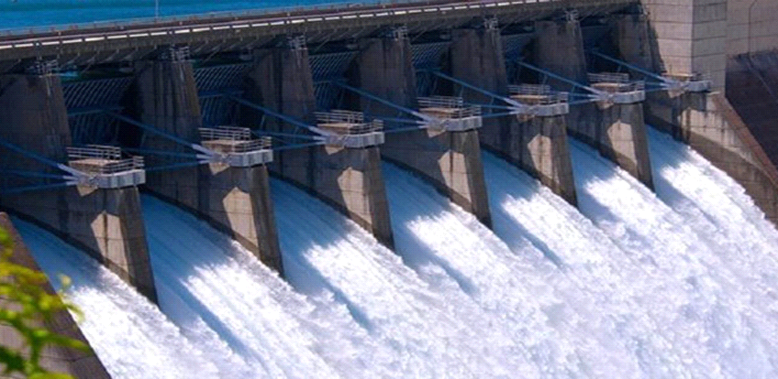

**The Water and Allied Resources Information and Management System**

**(WARIMS)**

**Department of Water Resources, River Development and Ganga Rejuvenation Ministry of Jal Shakti (MoJS)**

**Developed by**

**Bhaskaracharya National Institute for Space Applications and Geo-informatics (BISAG-N)**

**Ministry of Electronics and Information Technology (MeitY)**

**Government of India**

**The Water and Allied Resources Information and Management System**

**(WARIMS)**

**Department of Water Resources, River Development and Ganga Rejuvenation**

**Ministry of Jal Shakti (MoJS)**

**Developed by**

**Bhaskaracharya National Institute for Space Applications and Geo-informatics (BISAG-N)**

**Ministry of Electronics and Information Technology (MeitY)**

**Government of India**

**The Water and Allied Resources Information and Management System**

**(WARIMS)**

**Department of Water Resources, River Development and Ganga Rejuvenation**

**Ministry of Jal Shakti (MoJS)**

**Developed by**

**Bhaskaracharya National Institute for Space Applications and Geo-informatics (BISAG-N)**

**Ministry of Electronics and Information Technology (MeitY)**

**Government of India**

**Document Control**

**Revision History**

|  |  |  |
| --- | --- | --- |
| **Version** | **Issue Date** | **Changes** *[Section, Page(s) and Text Revised]* |
| [1.0] | 12-Nov-2024 | Initial Release |
|  |  |  |
|  |  |  |
|  |  |  |

**Project Stakeholders**

|  |
| --- |
| **Project Initiative for** |
| Department of Water Resources, River Development and Ganga Rejuvenation  Ministry of Jal Shakti (MoJS) |

|  |  |  |  |  |
| --- | --- | --- | --- | --- |
|  | **Role** | **Name** | **Signature** | **Date** |
| Prepared by | Document Designer | Dr. Yagnesh Vyas, Project Director, (BISAG-N, MeitY, GoI) |  |  |
| Reviewed by | Project Lead | Ms. Anita Brahmbhatt,  Project Manager  (BISAG-N, MeitY, GoI) |  |  |
| Approved by | Project Head | Mr. Khalid Mehmood,  Project Director  (BISAG-N, MeitY, GoI) |  |  |

**INDEX**

**Executive Summary iv**

**1 Introduction 1**

1.1 Governance Need 1

1.2 Project Endeavour 1

1.3 Measure of Success 2

1.4 Scope 2

1.5 End Users 2

**2 Solutions Specification 3**

2.1 Functional Requirements 3

2.2 Design Flow of Requirements 4

2.3 Technologies Utilized and Supported 8

2.4 System Architecture 9

2.5 Entity Relationship Diagram 12

2.6 Class Diagram 14

2.7 Algorithm 15

2.8 Process Involved in Data Integration and Development 16

2.9 Project Undertakings 17

**3 Project Plan 18**

3.1 Milestones 18

3.2 Phases and Tasks Detail 18

3.3 Project Schedule 19

3.4 Dependencies, Risk and Change Management 20

3.5 Software Testing 22

**4 User Manual 23**

4.1 Dashboard Landing Page 23

4.2 Access Land Use Land Cover (LULC) 24

4.3 Important Features 25

**5 Conclusion 41**

**6 Outcome 41**

**7 Future Scope 41**

**8 Ideation 41**

**9 References 42**

Annexure - 1: BSR of Land Use Land Cover (From NWIC) 43

Annexure - 2: Project Blueprint Synopsis 49

Annexure - 3: List of Figures-System Requirement, Design & Development 50

Annexure - 4: List of Figures: User Manual 51

Annexure - 5: List of Tables 52

Annexure - 6: Abbreviations 53

**Executive Summary**

This document outlines the specification, design and development for the WRIS-MIS-07 Land Use — Land Cover (LULC) within application WRIS- Land Resources for theme Master Information System (MIS). This is among nine themes of the project “Water and Allied Resources Information Management System” (WARIMS) platform developed by the Bhaskaracharya National Institute for Space Applications and Geo-informatics (BISAG-N), led by the Ministry of Jal Shakti (MoJS).

The primary objective of the LULC is to monitor and analyse changes in land use and land cover, which are critical for sustainable development and planning.

The National Remote Sensing Centre (NRSC) has established a threefold classification system for Nationwide LULC analysis, which is updated annually and mapped at various scales. The system utilizes high-resolution satellite data for LULC mapping, employing both raster and vector-based approaches to optimize the use of optical and microwave imagery.

The LULC maps and database are intended for use in scientific research, industrial siting, land improvement, watershed and coastal zone management, water resource management, agricultural productivity improvement, and other applications. The maps are produced at various administrative levels (country, state, district, basin, sub-basin) and include temporal changes displayed through maps, charts, and statistics.

The requirement specification specifies the input data required, which includes medium to high-resolution satellite sensor images and geospatial time-series data. The process involves data preparation, interpretation, ground truthing, post-classification correction, and output generation using both vector-based on-screen visual interpretation and raster-based image classification methods.

Responsibilities for data integration and development include syncing LULC classes with existing schemas, calculating LULC area statistics, and publishing web map services. The document also addresses data validation, software requirements, dependencies, risks, and change management.

In summary, the system provides a comprehensive framework LULC mapping system, which is essential for understanding land use patterns and their changes over time, ultimately supporting informed decision-making for sustainable land management and resource utilization.

1. **Introduction**

Geoviewer facilitates geographic visualization by focusing exclusively on information with a geospatial element. It serves as a comprehensive interface for viewing multiple spatial layers simultaneously, allowing users to gain a complete understanding of the collected data. Additionally, it offers a robust array of tools and techniques that enhance geo-spatial data analysis through improved visualization capabilities.

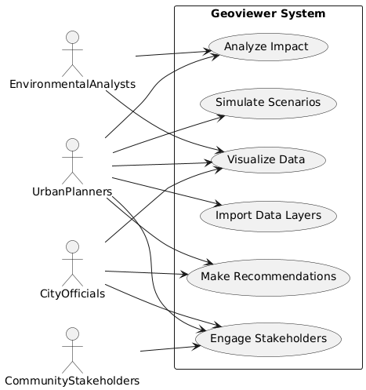

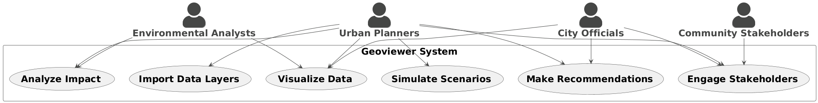Figure-1 UseCase Diagram for Geoviewer system

Figure-1 illustrates that The use case "Enhancing Urban Planning with Geoviewer" demonstrates how urban planners and stakeholders can leverage Geoviewer to improve urban development processes. Key participants include urban planners, city officials, environmental analysts, and community members. The scenario begins with the installation of Geoviewer and the availability of essential geospatial data layers, such as zoning maps and population density. Main activities involve integrating and visualizing these data layers, using analytical tools to assess the impacts of proposed developments, and simulating different development scenarios. Planners can share interactive visualizations with stakeholders to facilitate discussions and make informed recommendations based on the insights gained. This process leads to a comprehensive understanding of spatial dynamics and supports data-driven decisions for sustainable urban development. Additionally, the platform allows for the integration of new data and the export of visualizations for documentation. Overall, Geoviewer proves to be an invaluable tool for urban planners, enhancing their ability to analyze complex geospatial data and make effective planning decisions.

**1.1 Governance Need**

Geoviewer necessitates that spatial layers from other modules be hosted within this module.

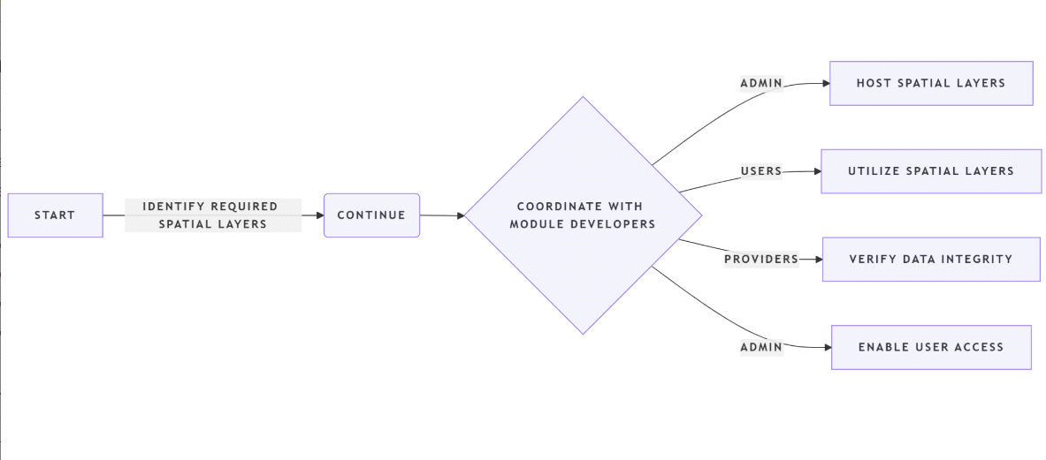

Figure-2 System flow of Geoviewer system

Figure-2 demonstrates that The use case for hosting spatial layers in Geoviewer involves the Geoviewer System Administrator identifying necessary spatial layers from other functional modules, collaborating with module developers to ensure compatibility, and hosting these layers within Geoviewer for accessibility. The administrator verifies the integrity and accuracy of the hosted layers before granting access to end users, including researchers, planners, and decision makers, who utilize the layers for data visualization, impact analysis, and informed decision-making. The process can be repeated for new spatial layers, and any compatibility issues may require further collaboration with developers to resolve.

**1.2 Project Endeavour**

Geoviewer is a geographic visualization tool that focuses on geospatial information, allowing users to view multiple spatial layers simultaneously for a comprehensive understanding of data. It offers various tools to enhance geospatial data analysis through improved visualization and requires spatial layers from other modules to be hosted within it.

**1.3 Measure of Success**

Hosted Data Layers are working and Web App is successfully running on the portal.

**1.4 Scope**

The requirements specified are related to the WARIMS, theme Self Service Analytics for WRIS-Utilities Application and the GeoViewer.

**High Priority:**

Land use serves as base for many applications and also as a model parameter required in many thematic studies.

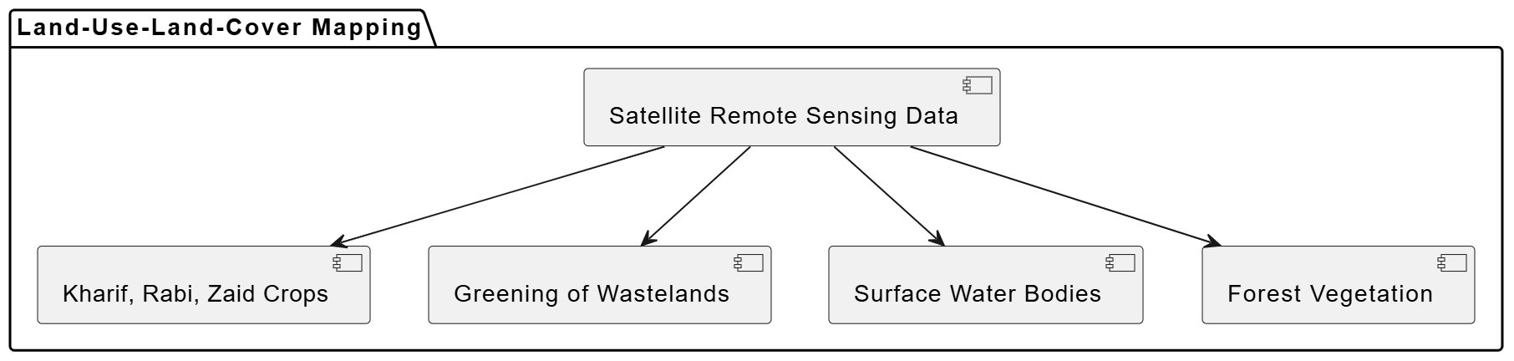

Figure-3 High Priority for LULC mapping

Land use land cover mapping addressing Kharif, Rabi and Zaid crops, greening of wastelands, seasonality of wastelands, surface water bodies, forest vegetation and other high temporal land use practices using satellite remote sensing data can provide a reliable database.

The LULC maps and database should be used at broad level for the following purposes:

* Scientific research involving carbon cycle, hydrologic cycle, energy budget studies, weather/climate prediction;
* Sitting of industries, SEZs etc;
* Land improvement programmes;
* Watershed management;
* Coastal zone management;
* Water resource management;
* Agricultural productivity improvement, etc.

**1.5 End Users:**

Researcher, Planners, Decision makers, administrators, academicians and public.

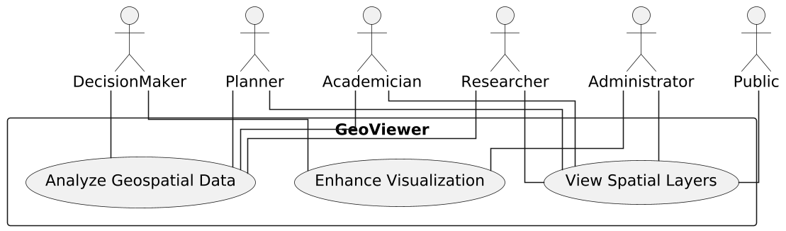

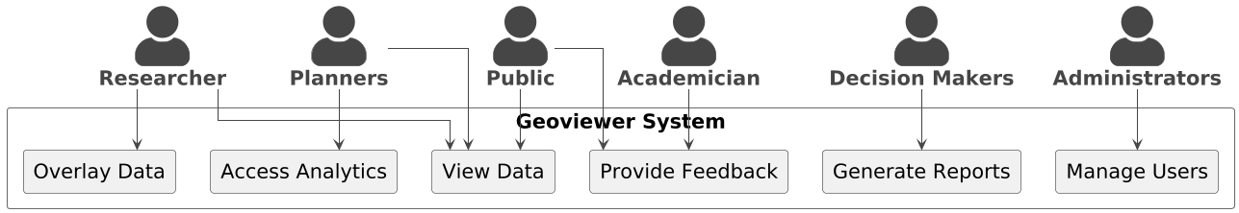

Figure-4 System Flow: End Users accessing GeoViewer

The diagram illustrates a use case model for a system called GeoViewer, which caters to various user roles by providing geospatial capabilities. The system supports six types of users: Decision Makers, Planners, Academicians, Researchers, Administrators, and the Public. These users interact with the system through three core functionalities. Decision Makers and Planners can analyze geospatial data to support strategic decisions and planning processes. Planners, Academicians, and Researchers can enhance visualization to better understand spatial patterns and insights. Meanwhile, Researchers, Administrators, and the Public can view spatial layers to explore and access spatial information. This structure ensures that each user role has access to the tools they need, whether for research, governance, or public awareness, fostering a versatile and inclusive geospatial platform.

**2. Solutions Specification**

**2.1 Functional Requirements**

The functional requirements are identified from the business specific requirement as received from the NWIC. Based on which the flowchart as shown in Figure-5 is designed to outline the process of Land Cover and Land Use (LULC) Monitoring. The flowchart is comprehensive framework to manage the LULC dynamics and provides visual representation of the various steps involved in LULC monitoring process.

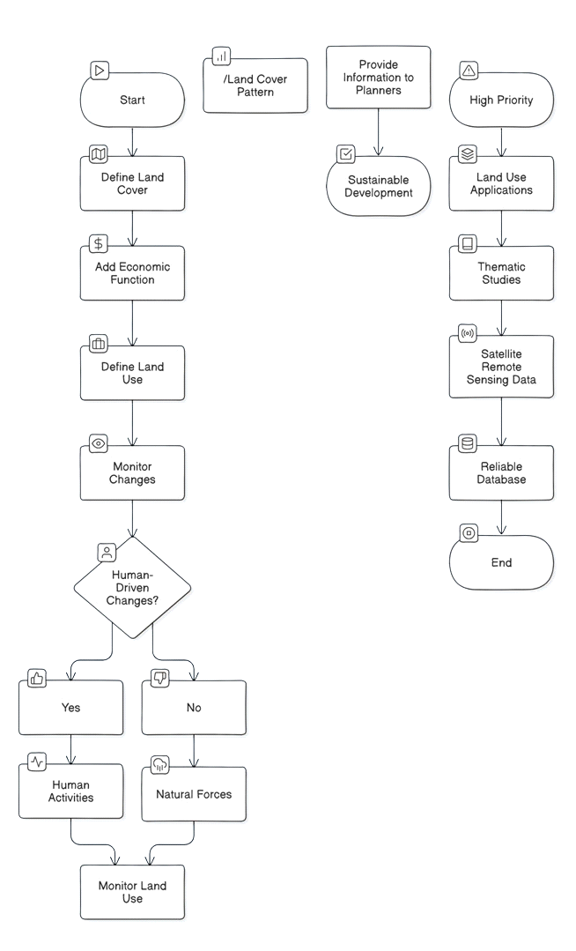

Figure-5 Flowchart: Functional Overview of LULC Monitoring

The flowchart outlines the key steps involved, from defining land cover and land use to monitoring changes and providing information for sustainable development. It also highlights the importance of considering both human activities and natural forces in driving land cover and land use changes.

**2.2 Design Flow of Requirements**

The design flows are represented for each feature of the requirement specifications as below:

**1) Visualization:-**

Geoviewer GUI can also be seen in the adjoining figure where various data layers can be overlaid as per users’ choice. (Example: Geoviewer, India WRIS).

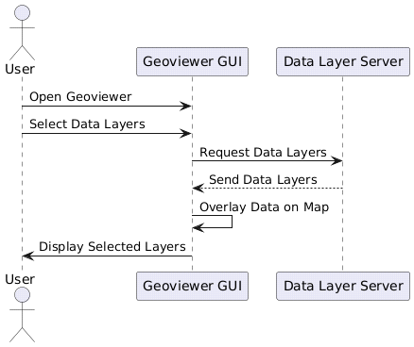

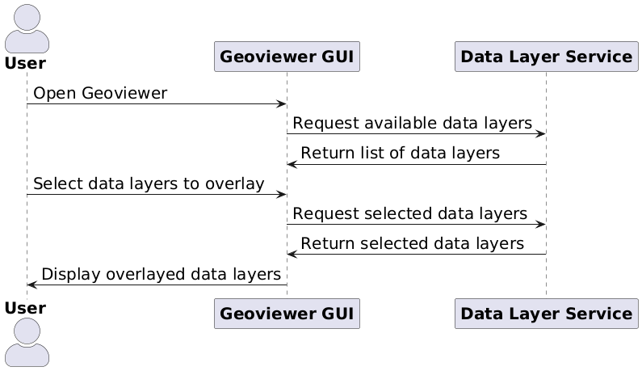

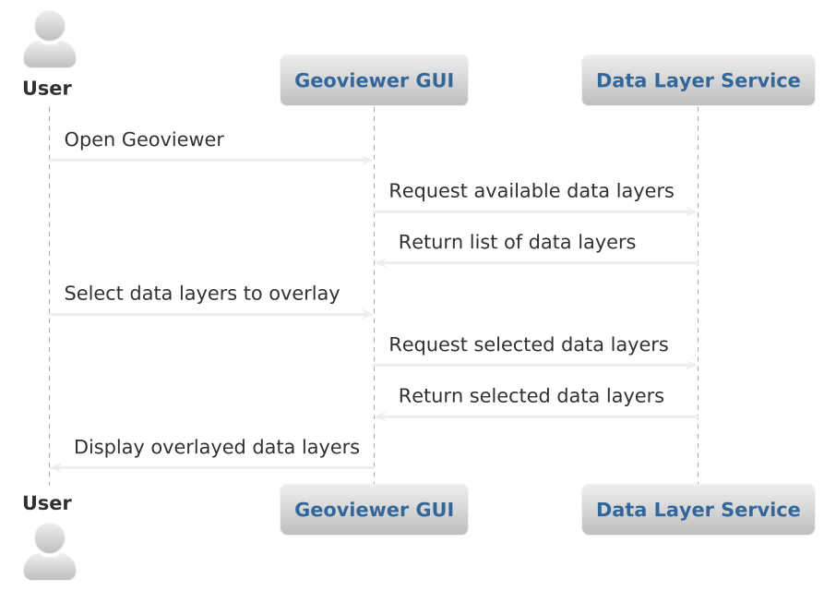

**Frequency :**

**Updates** are **performed regularly** whenever a **new data layer is added** from a new module or when an existing hosted geospatial layer is modified.

**2) Value Adding Instrumental Tools, Layers and Other Features:**

The system includes the component features like ThreeDTerrain, Navigations, Measure, Swipe Layers, Find Location, Buffer, Query Builder and Default Map. These components add value to the operations for LULC functions. The description of each component is mentioned in Table-1.

Table-1 Instrumental component features

|  |  |  |
| --- | --- | --- |
| **Sr. No.** | **Name of the**  **Instrumental DSS Components** | **Description** |
| 1 | ThreeDTerrain | The ThreeDTerrain is essential for terrain-based calculations in infrastructure projects like rivers, forests, and dams. It includes map layer display feature to visualize terrain directly on map interface, aiding analysis and decision-making. |
| 2 | Navigations | This component allows user to navigate from State > District > Taluka/ Tehsil/ Block > Village and user can analyse the required details. |
| 3 | Measure | This component measure distances, areas, offsets, and feature locations on a map or scene. User can draw line to measure length, draw a polygon to measure area, or click an individual feature to get measure info. |
| 4 | Swipe Layers | It helps to overlap and compare the 2 layers which could be utilize for temporal analysis, change detection etc. Select two desired layers from layers panel, and then select one of the selected layer as left which will be static and other as right which will slide over the later. |
| 5 | Find Location | It assists in locating positions with latitude and longitude (Degree Decimal) or by using grid numbers. Additionally, clicking on the map automatically displays the corresponding latitude and longitude coordinates. |
| 6 | Buffer | This component allows user to perform the proximity analysis of the required area. By selecting the area of interest and inputting required range for analysis on the map, infrastructure/ assets within the context/ range area will be displayed. |
| 7 | Query Builder | Query Builder provides a GUI for creating query in a simplified way to help users filter records within a particular data layer as per their requirement. Using this DSS component, user can filter layer-wise features to provide certain conditions on the attributes. |
| 8 | Default Map | At any given point of time user can navigate to standard default view of map using single click of this button. |

The value adding component features as shown in Table-1 supports to perform the functional tasks of different layers.

Moreover, LULC function includes layers and sub-layers to know the economic status and change analysis. Refer the Table-2 with the required selective options for each layer and sub-layers of LULC dynamics.

Table-2 Layers

|  |  |  |
| --- | --- | --- |
| **Sr. No.** | **Name of the Layers** | **Sub-Layers** |
| 1 | Administrative Boundary | * State * District * Sub-District * Village |
| 2 | Hydrological Boundary | * Basin * Sub-Basic * Water Shed * River * Major River * River Polygon |
| 3 | Base Map Gallery | * OpenStreet Map * High Resolution Map |
| 4 | Infrastructure | * Airports * Rail * Roads |
| 5 | Land Use - Land Cover | * Year (2005-2006) to Year (2022-2023) |

The system also includes some important features as mentioned in Table-3 with Selective Set-Up with available statistical and graphical representation files formats.

Table-3 Other Features

|  |  |  |
| --- | --- | --- |
| **Sr. No.** | **Features** | **Selective Set-Up** |
| 1 | Unit Wise Selection | * Hydrological Set-Up (Select Basin) * Administrative Set-Up (Select State) |
| 2 | Pre-defined Text Report | * Hydrological Set-Up   (Select Basin, Sub-Basin, Classes and Year)   * Administrative Set-Up   (Select State, District, Classes and Year) |
| 3 | Chart View | Land Use Land Cover Graphical Chart  (Pie Chart and Bar Chart) |
| 4 | Statistics | Land Use Land Cover Tabular Data  (Optional File Formats: CSV/Excel/PDF/DOC) |

Based on this requirement design flow the technology specification and the system architecture are defined further.

* **Technologies Utilized and Supported**

To develop the system as per the functional requirements, the scalable technology frameworks are utilized that can support even future needs. The technologies are enlisted in Table-4.

Table-4 Scalable Technologies and Framework (Utilized and Supported)

|  |  |
| --- | --- |
| Geospatial : | Image Processing and Remote Sensing Techniques |
| Web Application : | Java SpringBoot 4.0, GeoWebCache, JQuery 3.7.4 |
| Front-end : | OpenLayers 6, Thymeleaf 3.1.2, Bootstrap 5.3 (CSS & JS), HTML5 |
| GIS Software : | QGIS 3.32 Lima |
| Cloud : | MeghRaj, NIC |
| Database : | PostgreSQL 9.4 |

The significance of the technologies as enlisted in Table-4 are described in the below Table-5

Table-5: Significance described for each technology as mentioned in Table-4

|  |  |  |
| --- | --- | --- |
| **Sr.**  **No.** | **Technology** | **Description about the technology significance** |
| 1. | Geospatial Technologies | Image Processing and Remote Sensing Techniques are utilized to prepare the satellite imagery data for the application in GIS Environment. |
| 2. | Java Spring Framework :  SpringBoot | SpringBoot is built on top of conventional spring framework, widely used to develop REST APIs, supports Auto-configuration, provides Apache Tomcat, optimize line of code, Spring Security provides features to create secure Java Enterprise Applications. |
| 3. | GeoServer | GeoServer- GeoWebCache is a tiling server. It is Java web application used to cache map tiles coming from a variety of sources such as OGC Web Map Service (WMS). |
| 4. | QGIS | Open Source GIS software QGIS functions, are utilized to analyze and edit spatial information and mapping services. In addition to compose and export graphical maps. It supports raster, vector, mesh, and point cloud layers. It used to enhance capabilities to effectively classify satellite images and monitor changes with temporal data. |
| 5. | Thymeleaf | Thymeleaf is a modern server-side Java template engine which is used to emphasize the natural HTML templates that can be previewed in browser by double-clicking, to support independent work on UI templates without the need for a running server. |
| 6. | Bootstrap | Bootstrap is open source front-end development framework used to enable responsive web development. The extensive customization options are utilized, to modify colors, typography, spacing, and other visual aspects of its components. |
| 7. | OpenLayers | OpenLayers is an open source JavaScript framework utilized to render interactive maps from map tiles and vector data, to display and manipulate spatial data in web browser. It is used to display maps and perform operations such as data-driven visualization, geo-coding, routing, demographic analysis, and spatial analysis. |
| 8. | PostgreSQL | PostgreSQL, an Open Source relational database system that is used to handle and analyse location data. The key features utilized are PostGIS Extension, Spatial Indexing, Real-Time Analysis, and Integration with Mapping Systems. |
| 9. | MeghRaj, NIC | MeghRaj, NIC services are utilized in order to harness the benefits of Cloud Computing, Government of India. This ensures optimum utilization of infrastructure and speed up the development and deployment of e-Gov applications. For more detail, visit <https://www.meity.gov.in/content/gi-cloud-meghraj> |

* **System Architecture**

The architectures are designed for development of the functional needs by utilizing the technologies as mentioned in Table-7. The structure includes Data Architecture and GIS based System architecture for LULC. System architectures are kept scalable for future needs.

* **Data Management Architecture**

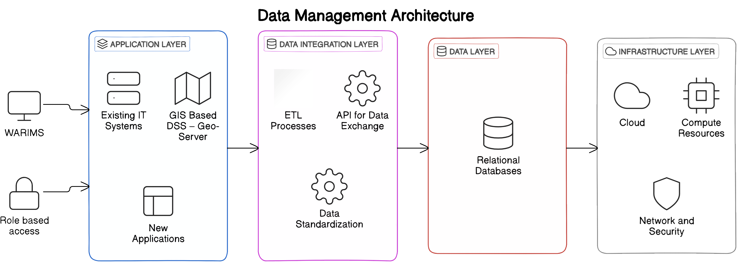

Figure-13 Data Architecture of the System

The Figure-13 depicts data management architecture, outlining the key components involved in managing and processing the flow of data from various sources through different processing stages and storage mechanisms, ultimately supporting decision-making and analysis for LULC data.

**Geospatial data management:**

Geospatial techniques, including remote sensing and image processing within GIS environment, are utilized to prepare the data. This involves utilizing high-resolution satellite imagery, supplemented by minimal field checks.

The remote sensing and image processing techniques are applied to harness satellite imagery for land cover data and to carry out data pre-processing, respectively.

The processed data is utilized to create detailed land use maps for LULC mapping, illustrating different land cover types. Temporal analysis is conducted to track changes in land use over time using historical data.

**Input Data Required**

|  |  |
| --- | --- |
| **Data Point** | **Data Source** |
| Administrative Boundary Layers | NWIC |
| Hydrological Boundary Layers | NWIC |
| Socioeconomic Layers | Census of India |
| Wetland Layers | NRSC |
| Glacial Lakes | CWC |
| Ground Water Prospects Study | NRSC |
| Surface Water Bodies | NWIC |
| Land Degradation | NRSC |
| Forest/Tree Cover | NRSC/FSI |
| Land Use Land Cover | NRSC/NWIC |
| Soil | NBSS & LUP |
| Coastline | RMSI |
| Water logging/Soil Salinity | CWC |
| Water Resource Projects | CWC |
| Inland Navigation Waterways | IWAI |
| Flood Inundation | NRSC |
| Reservoir Survey | CWC |
| Agro climatic/Agro ecological Layers | NITI Ayog/ICAR |
| Infrastructure | Airport Authority of India, NHAI, NRDB, Indian Railways |
| Reported Extreme Temperature, Rainfall & Earthquake Events | IMD |

**Data Validation:**

Geospatial layers need to be checked for working properly before hosting on Geoviewer.

* **GIS based Decision Support System Architecture**

The GIS based system architecture includes different layers and sub-layers of this decision support system. As shown below the Table-6 includes the description about the Main Layers and Sub-Layers of the GIS based System Architecture as shown in Figure-14.

Table- 6 System Design Layers

|  |  |
| --- | --- |
| **Main Layers** | **Sub-Layers** |
| * User Access Layer | * User Interface (UI): Web Platform and Dashboards * Access Control: Role-based access for administrators, planners, decision-makers, scientists, and citizens. |
| * Application Layer | * GIS-based Decision Support Systems (DSS): * Geo-Server: For GIS data serving and management. * Map Services: Integration with map services for visualization. * Existing IT Systems Integration * New Applications Development |
| * Data Integration Layer | * ETL: Extract, Transform, Load operations for data integration. * APIs: For data exchange between different systems and applications. * Data Standardization: Ensuring data consistency, quality. |
| * Data Layer | * Database: * Relational Databases: For structured data. |
| * Infrastructure Layer | * Cloud Infrastructure: * Cloud Platform: Infrastructure-as-a-Service (IaaS) and Platform-as-a-Service (PaaS) resources. * Compute Resources: Virtual machines, GPUs for processing power. * Storage Resources: High-capacity cloud storage for datasets. * Network Infrastructure: High-speed network for data transfer and accessibility. * Security Infrastructure: Firewalls, encryption, access controls for data security. |

The below Figure-14 depicts the process flow of the main layers and sub-layers



Figure-14 GIS based System Architecture

The Figure-14 shows the system architecture of GIS-based Decision Support System (DSS).

It outlines the various components involved in collecting, processing, and analysing spatial data to support decision-making used for LULC dynamics.

**Approach**

Geoviewer from India WRIS will be subsumed with additions for new as well as updated geospatial layers of WARIMS modules.

* **Entity Relationship Diagram**

The provided ER diagram in Figure – 15 illustrates a relationship between two major entities: lulc_subbasin and lulc_district of the LULC. It shows one-to-many relationship between two classes: **lulc_subbasin** and **lulc_district**.

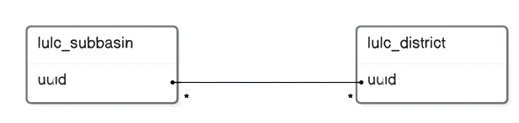

Figure-15 ER Diagram for LULC data

**Two Major Entities:**

* **lulc_subbasin:** Represents a subbasin unit, associated with LULC data.
* **lulc_district:** Represents a district unit, associated with LULC data.

**Unique Attribute**: “uuid” attribute is unique identifier, and is present in both entities.

Overall, ER diagram shows the relationship between sub-basins and districts, for organizing and managing LULC data.

**Data Attributes**

* **Geographical and Environmental Data Attributes:** The provided table in Figure-14 represents data attributes of geographical and environmental. It contains information about various spatial units and their attributes.
* **Entity:** The attributes represent "geographical_data".
* **Attributes:** The table includes attributes such as:

|  |  |
| --- | --- |
| **Identifiers:** | OBJECTID, uuid, subbasin, sbcode, basin, bacode. |
| **Temporal:** | Year |
| **Numerical:** | built_up, kharif_crop, rabi_crop, zaid_crop, double_triple_crop, current_fallow, plantation, evergreen_forest, deciduous_forest, degraded_scrub_forest, littoral_swamp, grassland, shifting_cultivation, wasteland, rann, waterbodies_max, waterbodies_min, snow_cover, basin_f, subbasin_f. |
| **Alias of the attributes** | Object ID, UUID, Sub Basin, Sub Basin Code, Basin, Basin Code, Year  Built Up, Kharif Crop, Rabi Crop, Zaid Crop, Double/Triple Crop, Current Fallow, Plantation, Evergreen Forest, Deciduous Forest, Degraded/Scrub Forest, Littoral Swamp, Grassland, Shifting_Cultivation, Wasteland, Rann, Maximum Area of Waterbodies, Minimum Area of Waterbodies, Snow Cover |

* **Land Use Land Cover Data Attributes:** The provided table in Figure-15 represents a data attributes of land use and land cover. It contains information about various spatial units and their attributes.
* **Entity**: The attributes represent data related to "land_use_cover".
* **Attributes**: The table includes attributes such as:

|  |  |  |
| --- | --- | --- |
| **Identifiers:** | uuid, district, dtcode, state, stcode. | |
| **Temporal:** | Year | |
| **Numerical:** | built_up, kharif_crop, rabi_crop, zaid_crop, double_triple_crop, current_fallow, plantation, evergreen_forest, deciduous_forest, degraded_scrub_forest, littoral_swamp, grassland, shifting_cultivation, wasteland, rann, waterbodies_max, waterbodies_min, snow_cover. | |
| **Textual:** | statename_f, distname_f. | |
| **Alias of the attributes** | Object ID, District, District LGD Code, State, State LGD Code, Year, Built Up, Kharif Crop, Rabi Crop, Zaid Crop, Double/Triple Crop, Current Fallow, Plantation, Evergreen Forest, Deciduous Forest, Degraded/Scrub Forest, Littoral Swamp, Grassland, Shifting_Cultivation, Wasteland, Rann, Maximum Area of Waterbodies, Minimum Area of Waterbodies, Snow Cover | |
| Figure-16 GIS & Environment Data Attribute | | Figure-17 LULC Data Attribute |
| The data-tables in the Figure-16 and Figure-17 stores data related to LULC, and other environmental factors for different spatial units (sub-basins, basins)/ (district, states). | | |

* **Class Diagram**

The class diagram as shown in the Figure-16 represents schema for a land use and land cover dataset. It consists of two main classes: **lulc_subbasin** and **lulc_district.**

* **lulc_subbasin class -** Contains attributes for subbasin-level information, such as:
* subbasin_f (character varying): Subbasin name
* sbcode (character varying): Subbasin code
* basin_f (character varying): Basin name
* bacode (character varying): Basin code
* statename_f (character varying): State name
* stcode (character varying): State code
* **lulc_district class -** Contains attributes for district-level information, such as:
* OBJECTID (double precision): Unique identifier
* year (double precision): Year
* built_up (double precision): Built-Up
* kharif_cro (double precision): Kharif Crops
* rabi_crop (double precision): Rabi Crops
* zaid_crop (double precision): Zaid Crops
* double tri (double precision): Double/Triple Crops
* current_fa (double precision): Current Fallow
* plantation (double precision): Plantations
* evergreen_ (double precision): Evergreen Forest
* deciduous (double precision): Deciduous Forest
* degraded_s (double precision): Degraded/Scrub Forest
* littoral s (double precision): Littoral Swamp
* grassland (double precision): Grassland
* shifting_c (double precision): Shifting Cultivation
* wasteland (double precision): Wasteland
* rann (double precision): Rann
* waterbodie (double precision): Maximum area of Water Bodies
* waterbod 1 (double precision): Minimum area of Water Bodies
* snow_cover (character varying): Snow Cover

In Figure-18, refer the Class Diagram for lulc_subbasin class and lulc_district class.

|  |  |
| --- | --- |
| Figure-18 Class Diagram of classes: lulc_subbasin and lulc_district | |
| **lulc_subbasin class**:  Has one-to-many relationship with the lulc_district class, where one subbasin can have multiple districts. | **lulc_district class**:  Has foreign key relationship with lulc_subbasin class, referencing subbasin attribute to establish connection between subbasin and district. |

Overall, the class diagram in the Figure-18 provides suitable structure for storing and managing LULC data at both subbasin and district levels, to analyze and compare LULC changes over period of time.

**2.7 Algorithm**

Geospatial layers are generated from data received from data agencies in form of tables, pdfs, reports, shape files, geodatabases, etc. These layers are shared using ESRI QGIS server through Web app which will be hosted in the module. GIS based tools such as egend, Layer list, Base map, Print, Surface profile, Share, Add Data, Zoom in/Zoom Out, Previous/Next Zoom, Locate, Global Search, Attribute table, Select, Swipe, Measurement, Bookmark etc. will be provided. This will enable user for querying through data for desired results.

Different data layers to be shared on Geoviewer include the following list:

* Administrative Boundary Layers
* Hydrological Boundary Layers
* Socioeconomic Layers
* Wetland Layers
* Glacial Lakes
* Ground Water Prospects Study
* Surface Water Bodies
* Land Degradation
* Forest/Tree Cover
* Land Use Land Cover
* Soil
* Coastline
* Water logging/Soil Salinity
* Water Resource Projects
* Inland Navigation Waterways
* Flood Inundation
* Reservoir Survey
* Agro climatic/Agro ecological Layers
* Infrastructure
* Reported Extreme Temperature, Rainfall & Earthquake Events

These GIS data layers will be published in QGIS Enterprise. A web-app named Geoviewer using published layers with GIS functionalities/tools for users will then be published in QGIS Enterprise. This app will then be hosted on the geoportal. Some of the GIS tools are shown.

1. Various Data layer list hosted on Geoviewer
2. Swiping various data layers on map panel in GeoViewer
3. Adding More layers on map panel in GeoViewer

**2.8 Process involved in data integration and development**

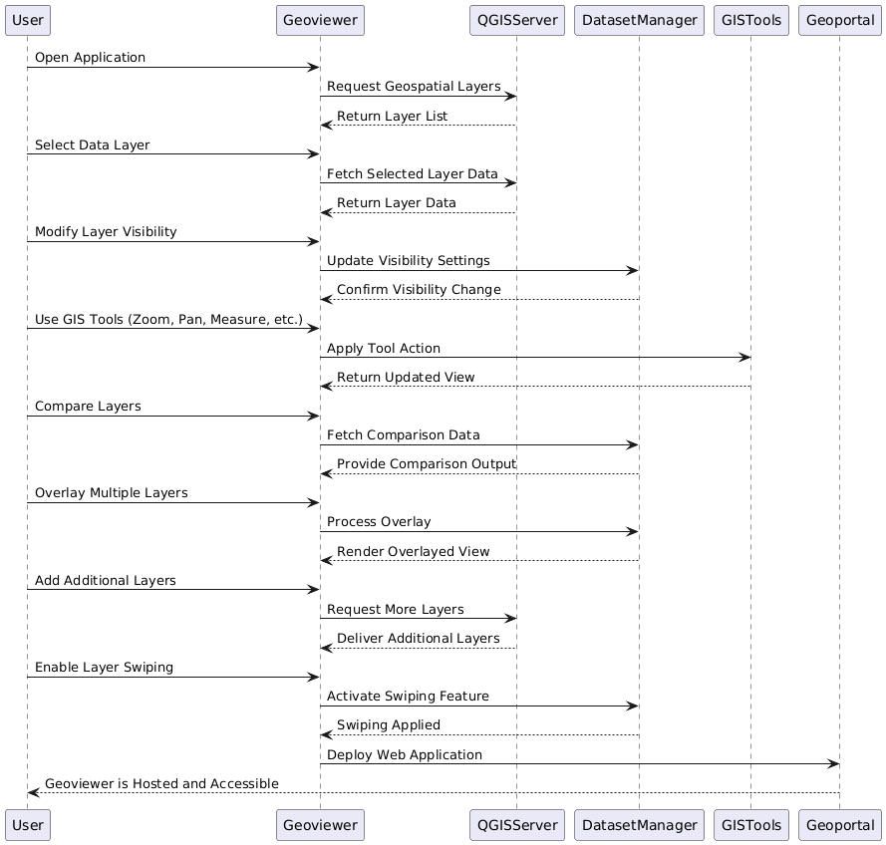  
Figure-19 Sequence Diagram of Data Integration and Development

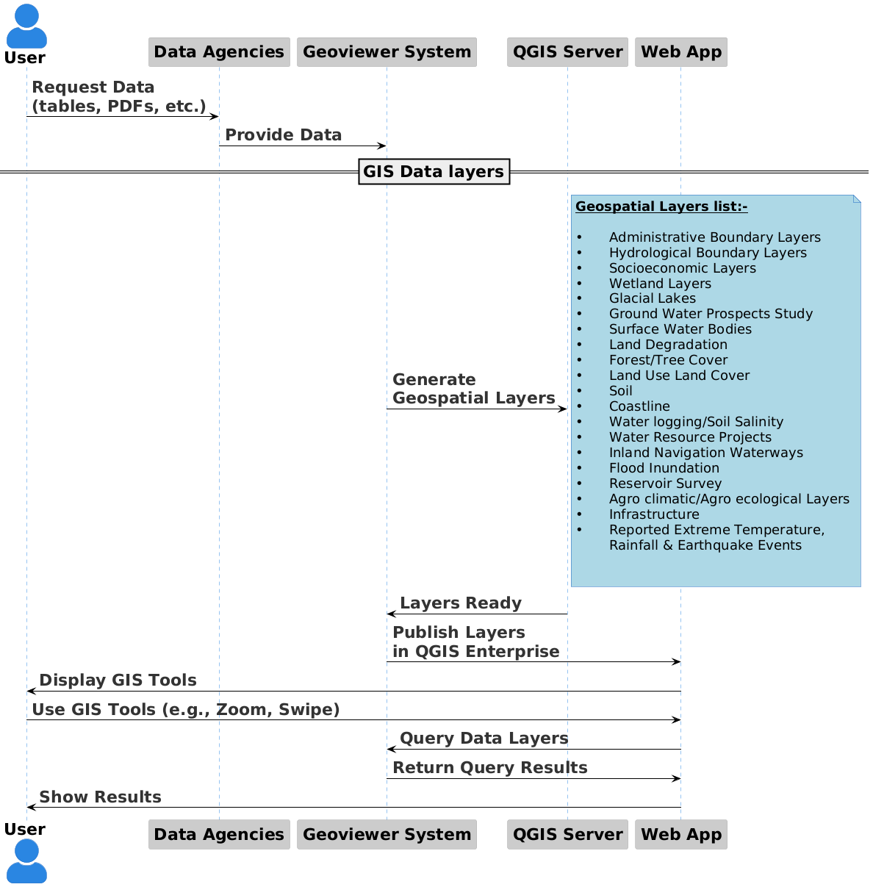

**2.9 Project Undertakings**

Below in the Table-7 are the undertakings defined for the BISAG-N and NWIC, respectively.

Table- 7 Undertakings

|  |  |
| --- | --- |
| **BISAG-N** | **NWIC** |
| * Design, Development and Deployment over cloud * Technical support * Providing of hosting servers and other software. * Standard Testing at PoC development level. * Operations and Maintenance (O&M) including Knowledge Transfer, Capacity Building & Training | * Overall project co-ordination, monitoring, guidance and support required for the project. * NWIC shall obtain and provide all the technical data, reports etc. required for the project. * NWIC shall appraise the project progress to the committee constituted to oversee WARIMS project implementation * Collaborate on requirement finalization and approval of designs and developments * User Acceptance Testing (UAT) |

Accordingly, the further project plan and milestones are defined to develop the project requirements for the: Land Use Land Cover (LULC).

**3.Project Plan**

The project plan includes the milestone, phases, tasks, estimated and scheduled timeline, dependencies, risks and change management process for the system development.

**3.1 Milestones**

* The milestones are planned for design, development, testing and deployment of the system.
* Milestone-1: Requirement Specification: Understanding and Analysis
* Milestone-2: System Design
* Milestone-3: System Development
* Milestone-4: System Quality Testing
* Milestone-5: User Acceptance Test (UAT).
* Table-8 as shown below provides the details about the milestones, phases, estimated timeline and resource allocation for the system development of the -Land Use Land Cover.

Table –8: Project Milestones*

|  |  |  |  |
| --- | --- | --- | --- |
| **Milestones** | **System Development Phases** | **Total Effort (Estimated Work Days)** | **Team** |
| 1 | Requirement:  Understanding and Analysis & Review | 5 | Project Manager and Project Analyst |
|
|
|
| 2 | System Design | 3 | UI/UX Graphics and  Web Designer |
|
|
|
| 3 | System Development | 10 | Software Developers |
| 4 | System Quality Testing | 2 | Software Quality Tester |
| 5 | User Acceptance Test (UAT) | 5 | NWIC |
|

**\***Time may negligibly vary for specific tasks dependencies/risk/change where requirements may be critical. It is planned, monitored and reviewed by the project manager.

**Phases and Tasks Detail**

The required tasks are defined for each phase and the resources are assigned to accomplish those tasks as per project plan.Table-9 defines phases of each milestone. In same table, tasks of each phase are defined with details of resource allocation to accomplish that particular task of the phase. The project development phases and tasks are planned, monitored and reviewed by project manager and reported to project director.

* Table-9: Project Development Phases and Tasks*

|  |  |  |
| --- | --- | --- |
| **System Development Phases** | **Tasks Details** | **Assigned to** |
| Requirement:  Understanding and Analysis & Review | Requirement Understanding | Project Manager and Project Analyst |
| Requirement Analysis |
| Data Availability | GIS Analyst |
| Stakeholder Co-ordination | Project Analyst |
| System Design | Wireframe | Project Analyst / UI/UX Graphics Designer |
| Approval from Stakeholder | NWIC |
| Designing | Web Designer |
| Review and Feedback | NWIC and MoJS Internal Agencies |
| System Development | Development and Deployment | Project Manager and Software Developers |
| System Quality Testing | Functional Testing | Project Analyst & Software Quality Tester |
| User Acceptance Test (UAT) | Feedback | NWIC, Domain Agency |
| Go-Live | - |

Whereas, Table-10 displays the number of personnel from BISAG-N assigned to accomplish the corresponding tasks of each phase and milestone.

* Table-10: Project Development Resources

|  |  |  |
| --- | --- | --- |
| **Sr. No.** | **Role** | **Number of Personnel** |
| 1 | Project Director | 1 |
| 2 | Project Manager | 1 |
| 3 | Cloud Engineer | 1 |
| 4 | Software Developers | 2 |
| 5 | Software Quality Tester | 1 |
| 6 | Database Administrator | 1 |
| 7 | UI/UX Designer | 1 |
| 8 | Project Analyst / GIS Analyst | 1 |
|  | Total | 9 |

[https://www.projectmanager.com/templates/resource-plan-template?utm_source=project_manager_com HYPERLINK "https://www.projectmanager.com/templates/resource-plan-template?utm_source=project_manager_com&utm_medium=content+library&utm_campaign=word-proj-plan&utm_content=&utm_detail=&utm_term=none"& HYPERLINK "https://www.projectmanager.com/templates/resource-plan-template?utm_source=project_manager_com&utm_medium=content+library&utm_campaign=word-proj-plan&utm_content=&utm_detail=&utm_term=none"utm_medium=content+library HYPERLINK "https://www.projectmanager.com/templates/resource-plan-template?utm_source=project_manager_com&utm_medium=content+library&utm_campaign=word-proj-plan&utm_content=&utm_detail=&utm_term=none"& HYPERLINK "https://www.projectmanager.com/templates/resource-plan-template?utm_source=project_manager_com&utm_medium=content+library&utm_campaign=word-proj-plan&utm_content=&utm_detail=&utm_term=none"utm_campaign=word-proj-plan HYPERLINK "https://www.projectmanager.com/templates/resource-plan-template?utm_source=project_manager_com&utm_medium=content+library&utm_campaign=word-proj-plan&utm_content=&utm_detail=&utm_term=none"& HYPERLINK "https://www.projectmanager.com/templates/resource-plan-template?utm_source=project_manager_com&utm_medium=content+library&utm_campaign=word-proj-plan&utm_content=&utm_detail=&utm_term=none"utm_content= HYPERLINK "https://www.projectmanager.com/templates/resource-plan-template?utm_source=project_manager_com&utm_medium=content+library&utm_campaign=word-proj-plan&utm_content=&utm_detail=&utm_term=none"& HYPERLINK "https://www.projectmanager.com/templates/resource-plan-template?utm_source=project_manager_com&utm_medium=content+library&utm_campaign=word-proj-plan&utm_content=&utm_detail=&utm_term=none"utm_detail= HYPERLINK "https://www.projectmanager.com/templates/resource-plan-template?utm_source=project_manager_com&utm_medium=content+library&utm_campaign=word-proj-plan&utm_content=&utm_detail=&utm_term=none"& HYPERLINK "https://www.projectmanager.com/templates/resource-plan-template?utm_source=project_manager_com&utm_medium=content+library&utm_campaign=word-proj-plan&utm_content=&utm_detail=&utm_term=none"utm_term=none](https://www.projectmanager.com/templates/resource-plan-template?utm_source=project_manager_com&utm_medium=content+library&utm_campaign=word-proj-plan&utm_content=&utm_detail=&utm_term=none)

* **Project Schedule**

The project plan for different phases and tasks of each milestone is executed and is defined with actual timeline in the project schedule.

Table-11 presents a summarized project schedule outlining the phases and tasks associated with the milestones necessary for the development of the Land Use Land Cover.

Table-11: Project Schedule

|  |  |  |  |  |
| --- | --- | --- | --- | --- |
| **Task No.** | **Task Name** | **Start Date** | **End Date** | **Duration (Days)\*** |
| 1 | Requirement Specification Understanding | 6-Oct-23 | 7-Oct-23 | 1 |
| 2 | Requirement Specification Review and Analysis | 6-Oct-23 | 7-Oct-23 | 1 |
| 3 | Data Availability | 6-Oct-23 | 7-Oct-23 | 1 |
| 4 | Designing | 7-Oct-23 | 9-Oct-23 | 2 |
| 5 | Visualization on Map at country to State/District/Basin/Sub-Basin Level. | 9-Oct-23 | 11-Oct-23 | 2 |
| 6 | Filtering options for data (forest type wise) need to be provided. Category/class wise data visualization should be admin-wise (different states up to district) or hydrological boundary-wise (Basin up to sub basin). | 11-Oct-23 | 17-Oct-23 | 6 |
| 7 | Graphical data presentation should be both pie diagrams and Bar charts. | 15-Oct-23 | 20-Oct-23 | 5 |
| 8 | Class wise distribution of Area based upon Hydrological and Administrative | 12-Oct-23 | 15-Oct-23 | 3 |
| 9 | Comparison between two consecutive year with for all classes and also for single class. | 15-Oct-23 | 22-Oct-23 | 7 |
| 10 | Classes wise data mentioned in data panel. And Year wise data mentioned in the data panel. | 11-Oct-23 | 17-Oct-23 | 6 |
| 11 | Data Year drop down list available for user in the Data panel. | 13-Oct-23 | 14-Oct-23 | 1 |
| 12 | Comparison between two consecutive year with for all classes and also for single class. | 15-Oct-23 | 22-Oct-23 | 7 |
| 13 | Data Year drop down list available for user in the Data panel | 25-Oct-23 | 26-Oct-23 | 1 |
| 14 | Predefine Report Generate | 1-Nov-23 | 5-Nov-23 | 4 |
| 15 | In Comparison Added Swipe tool | 10-Jan-24 | 13-Jan-24 | 3 |
|  | User Acceptance Testing (UAT) | (NWIC) | | |
|  | Go-Live | - | - | - |

*The duration is estimated for each task based on its dependencies on other tasks and perform those tasks simultaneously to try and achieve the estimated timeline of the project.

Along with the project schedule, the Gantt chart is essential for several reasons like visual representation, task tracking, dependency management, resource planning & allocation and progress monitoring of the overall project management.

Figure-20 Gantt chart

Figure-20 demonstrates the Gant chart which is based on the project schedule.

The Gantt chart provides the information of tasks that are completed on specific timeline. The horizontal bar represents the duration of each task, which helps in identifying the dependencies and review the status of each task throughout the project development.

* **Dependencies, Risk and Change Management**

In project management, effectively managing risk, dependencies, and changes are crucial for success. Below are the key factors that are identified for Dependencies, Risk and Change Management within the project.

Understanding these interrelated elements enhances project resilience and facilitates smoother execution and delivery.

**3.4.1 Dependencies:**

Dependencies define the relationships between tasks, influencing their sequence and highlighting how delays can affect the overall timeline.

**List of key Dependencies:**

* Non-availability of appropriate season data sometimes put constraints on the interpretation of the features owing to poor reflectance of data, cloud conditions/images and other phenological changes.
* Incomplete or manipulated data (Interpretational errors).
* Registration errors when using old SOI toposheet for reference purpose. Unmatched GIS layer feature area with published statistics. Generally, raster and vector classification output doesn’t match due to difference in mapping approach.
* Software solutions and trainings are highly required in working with High Resolution Microwave Image.

**3.4.2 Risk Management:**

Risks are potential events that could negatively impact project goals, and early identification allows for the development of mitigation strategies. Performing risk management entails various risks and challenges.

At different stages of project, below are potential risks that were mitigated during project:

* The risk of requirements management of the project is mitigated by clear communication with stakeholders, coordinate data collection, document requirements, and verify understanding regularly.
* The risk of UI/UX design is mitigated by user-friendly design principles and tested usability.
* The robust data architecture systems with suitable validations are implemented to mitigate the risk of data quality management.
* The risk of coding standard and code audit are mitigated with code review and audit by qualified developers, prioritized critical issues, and allocate resources efficiently.
* The project code testing is done with standard testing practices and compared output.
* The risk configuration issues are mitigated by using cloud setup of MeghRaj, by NIC.

[https://www.projectmanager.com/templates/risk-tracking-template?utm_source=project_manager_com HYPERLINK "https://www.projectmanager.com/templates/risk-tracking-template?utm_source=project_manager_com&utm_medium=content+library&utm_campaign=word-proj-plan&utm_content=&utm_detail=&utm_term=none"& HYPERLINK "https://www.projectmanager.com/templates/risk-tracking-template?utm_source=project_manager_com&utm_medium=content+library&utm_campaign=word-proj-plan&utm_content=&utm_detail=&utm_term=none"utm_medium=content+library HYPERLINK "https://www.projectmanager.com/templates/risk-tracking-template?utm_source=project_manager_com&utm_medium=content+library&utm_campaign=word-proj-plan&utm_content=&utm_detail=&utm_term=none"& HYPERLINK "https://www.projectmanager.com/templates/risk-tracking-template?utm_source=project_manager_com&utm_medium=content+library&utm_campaign=word-proj-plan&utm_content=&utm_detail=&utm_term=none"utm_campaign=word-proj-plan HYPERLINK "https://www.projectmanager.com/templates/risk-tracking-template?utm_source=project_manager_com&utm_medium=content+library&utm_campaign=word-proj-plan&utm_content=&utm_detail=&utm_term=none"& HYPERLINK "https://www.projectmanager.com/templates/risk-tracking-template?utm_source=project_manager_com&utm_medium=content+library&utm_campaign=word-proj-plan&utm_content=&utm_detail=&utm_term=none"utm_content= HYPERLINK "https://www.projectmanager.com/templates/risk-tracking-template?utm_source=project_manager_com&utm_medium=content+library&utm_campaign=word-proj-plan&utm_content=&utm_detail=&utm_term=none"& HYPERLINK "https://www.projectmanager.com/templates/risk-tracking-template?utm_source=project_manager_com&utm_medium=content+library&utm_campaign=word-proj-plan&utm_content=&utm_detail=&utm_term=none"utm_detail= HYPERLINK "https://www.projectmanager.com/templates/risk-tracking-template?utm_source=project_manager_com&utm_medium=content+library&utm_campaign=word-proj-plan&utm_content=&utm_detail=&utm_term=none"& HYPERLINK "https://www.projectmanager.com/templates/risk-tracking-template?utm_source=project_manager_com&utm_medium=content+library&utm_campaign=word-proj-plan&utm_content=&utm_detail=&utm_term=none"utm_term=none](https://www.projectmanager.com/templates/risk-tracking-template?utm_source=project_manager_com&utm_medium=content+library&utm_campaign=word-proj-plan&utm_content=&utm_detail=&utm_term=none)

**3.4.3 Change Management**

Changes that often arise from evolving requirements or unforeseen circumstances need to be managed carefully to maintain alignment with project objectives and stakeholder expectations.

Table-12 Change Management*

|  |  |  |  |
| --- | --- | --- | --- |
| **Change Log No.** | **Change Details** | **Updated Date** | **Status** |
| 1 | Graph axis details and legends should be proper. | 15/10/23 | Completed |
| 2 | Percentage column should be added in the table. | 20/01/24 | Completed |
| 3 | Table column title should be reframe in proper format | 19/01/24 | Completed |
| 4 | Thousand separators should be placed in graph and table in all hierarchy. | 19/01/24 | Completed |
| 5 | Unit of Area should be shown in the data panel. | 19/01/24 | Completed |
| 6 | In swipe tool, year to be mentioned below the bar as well as vertical line should be placed on the map and latest year data should be on the top LULC (WRIS-MIS-07) | 12/04/24 | Completed |

*Later to the development completion, and unless there are critical changes, any further queries will be handled through support.

Table-12 defines the status about each of the change performed during the project development after clear communication between the stakeholders.

* **Software Testing**

The software testing is performed for thorough and comprehensive evaluation.

The project development is followed by testing checklist to ensure comprehensive evaluation.

Usually, there are many different tests in software development like Stored HTML, Malicious File Upload, Session Hijacking, OTP Bypass, SQL Error, Clear Text Credentials, Account Lockout Issue, Improper Error Handling, Concurrent Login, OTP & Form Bombarding, Outdated JQuery and Bootstrap, Improper Input Validation, Local IP Disclosure, CSP Header Missing, Auto Complete Enabled, Cookie w/o Same Site Attribute, and others. Table-13 enlists testing checklist of standard practice that were based on the requirement specification of LULC project development.

Table-13: Testing Checklist

|  |  |  |
| --- | --- | --- |
| **Sr. No.** | **Testing Checklist** | **Preventive Measures within Development** |
| 1. | Stored HTML Injection | Have validated and sanitized user inputs, and have implemented proper encoding before rendering content. |
| 2. | Session Hijacking | Have used HTTPS, enforced secure cookie attributes, and regenerated session IDs after login. Implemented session timeouts, monitor concurrent sessions, and notify users on log-out. Track IP addresses for anomalies and employ Cross-Site Request Forgery protection. IP addresses are encrypted. |
| 3. | SQL Error | Used prepared statements, system will validate user inputs, implemented proper error handling, and leverage Object Relational Mapping frameworks like Hibernate. |
| 4. | Improper Error Handling | Used centralized exception handling with @ControllerAdvice and log errors w/o exposing sensitive information. Provided user-friendly error messages and stack traces are hidden from end users. |
| 5. | Outdated JQuery and Bootstrap | Regularly update to the latest version, use a package manager for dependency management. Monitor for security vulnerabilities with automated tools. |
| 6. | Improper IP Validation | Used trusted libraries for strict validation of IPv4 and IPv6 formats and implemented whitelisting/blacklisting for IP addresses. Incorporated rate limiting to control requests and sanitize all user inputs. Done regular log access attempts and validated logic. |
| 7. | Local IP Disclosure | It is ensured that error messages and logs do not expose internal IP addresses and configure firewalls to restrict external access. Environment variables are used to manage IP addresses and set server.address in application.properties to bind the server to a specific interface. Additionally, logging settings to avoid logging sensitive information and implement security headers to mitigate exposure risks is configured. |

Whereas, the User Acceptance Testing will be performed by NWIC.

**4. User Manual:**

Refer this user manual detail to walk-through and understand the LULC.

The link of the Platform [WARIMS (ncog.gov.in)](WARIMS%20(ncog.gov.in)) is: [*https://cache.ncog.gov.in/WARIMS/*](https://cache.ncog.gov.in/WARIMS/login)

* **Dashboard Landing Page**

The exhaustive Proof of Concept consists of multiple use cases and scenarios as per the finalized

requirements by the core committee. In Figure-21, the dashboard of the landing page is as below:

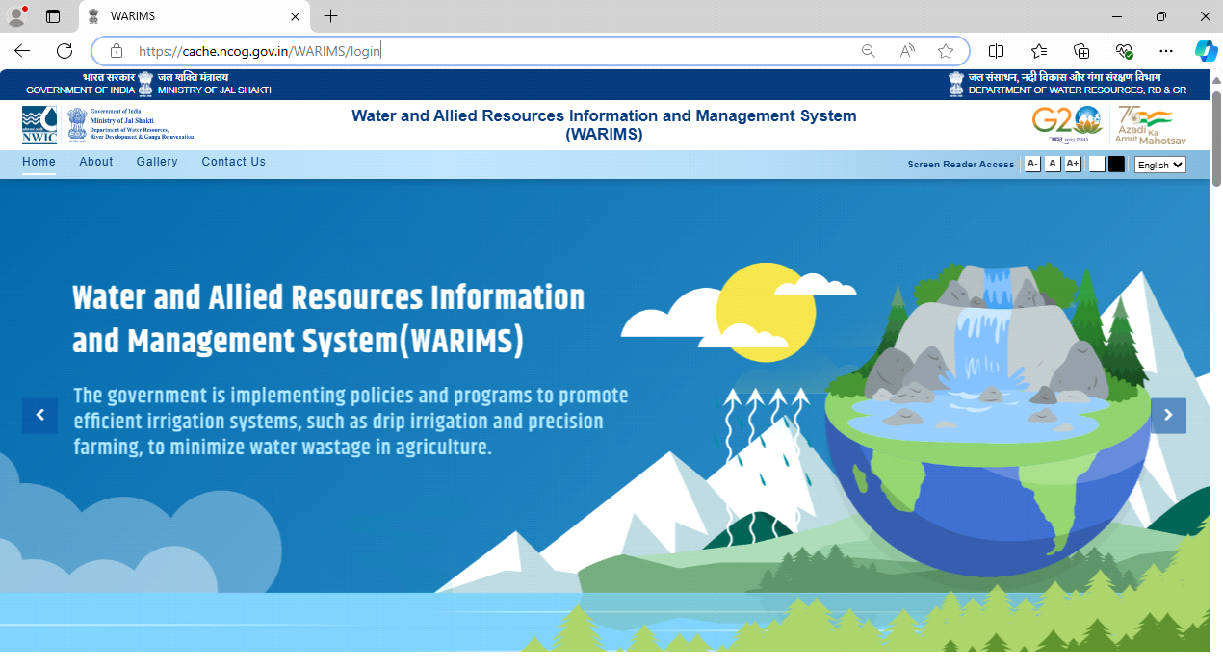

Figure-21 Dashboard Landing Page

Figure-22 shows the themes displayed in the dashboard of the landing page. User will select particular theme to access the Application and its Use Case.

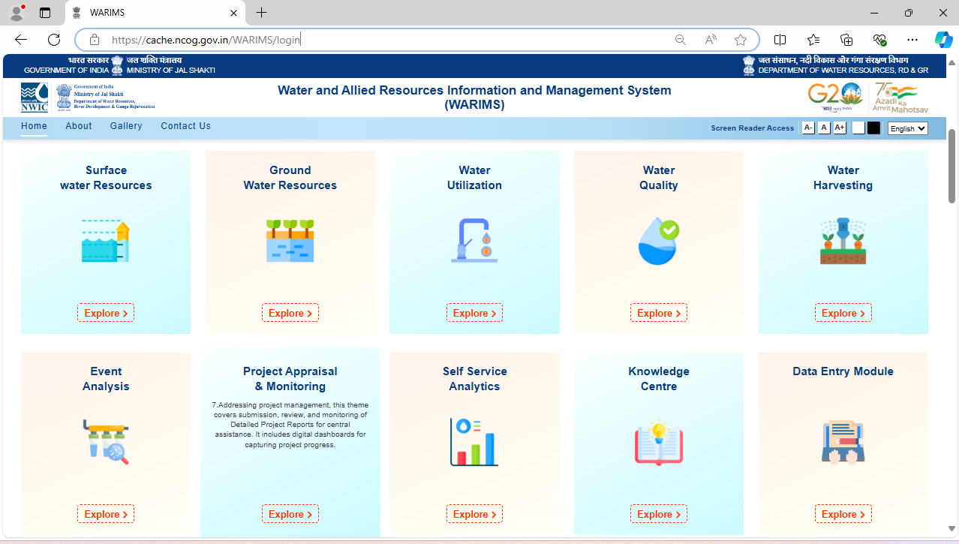

Figure-22 Themes on the Dashboard Landing Page

**4.2 Access the Land Use Land Cover**

As shown in Figure-23 follow the below steps to access the LULC in the WARIMS platform.

Steps:

Select → Surface Water Resources → Master Information System → Land Use Land Cover

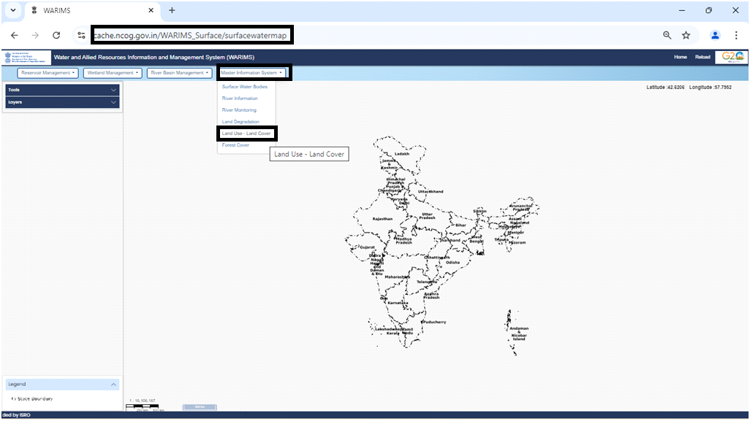

Figure-23 Access Land Use Land Cover (LULC)

Figure-24 shows the initial page of the: Land Use Land Cover (LULC)

of Application: WRIS – Land Resources, and Theme: Master Information System

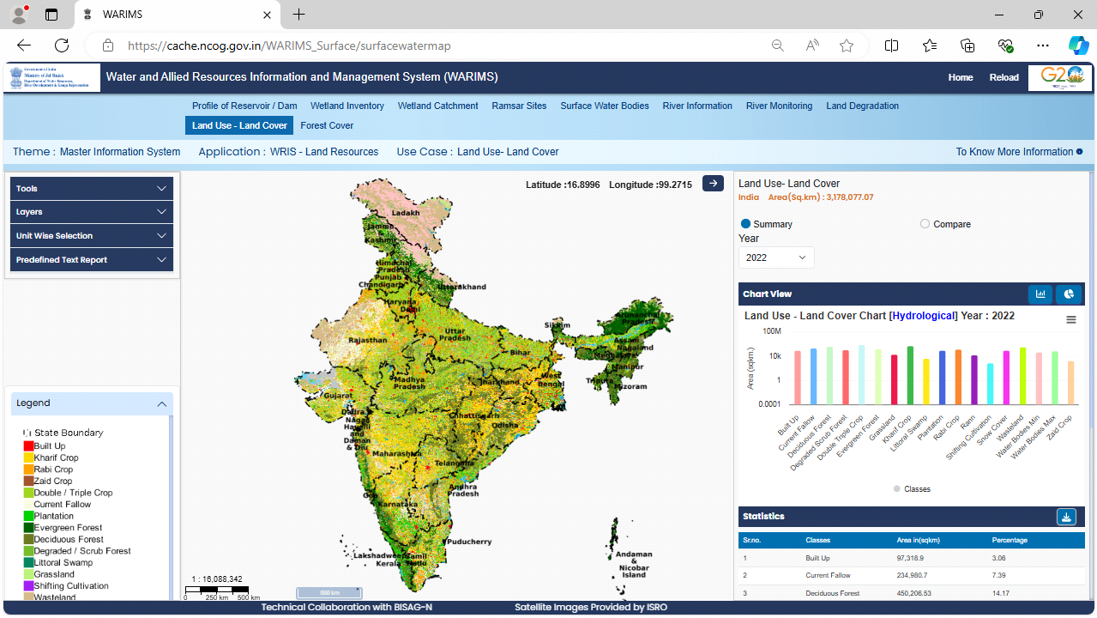

Figure-24 Home Page of the Land Use Land Cover (LULC)

* **Important Features**

The Important features of the LULC include:

* Tools
* Layers
* Unit Wise Selection
* Predefined Text Report
* Legend
* Summary and Comparison (Year Wise) using Chart View (Bar Chart / Pie Chart) and
* Statistics Report

Let us see the functionality of each of these features.

**4.3.1 Feature Tools**

The Figure-25 highlights the “Tools” options in the Left Side Vertical Menu.

The Tools includes the following features:

|  |  |
| --- | --- |
| * ThreeDTerrain * Navigations * Measure * Swipe Layers | * Find Location * Buffer * Query Builder * Data Report from Query Builder * Default Map |

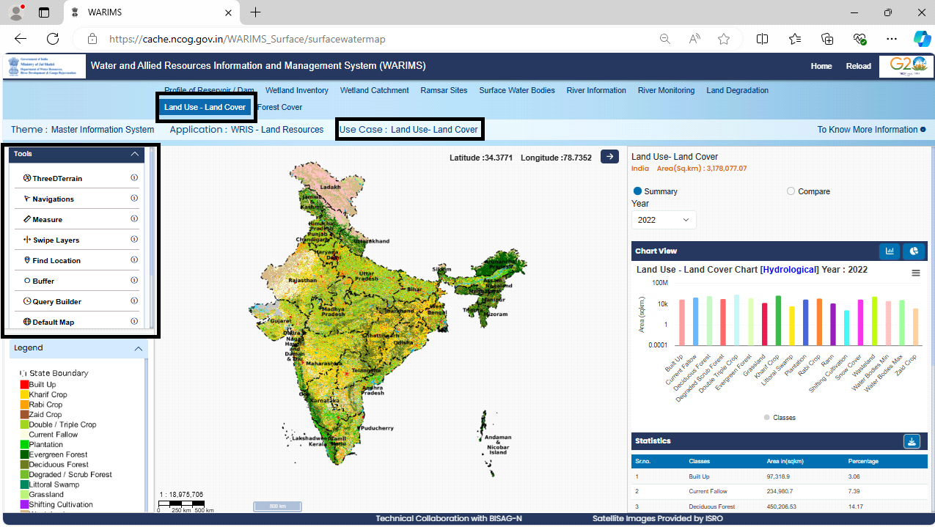

Figure-25 Component Features (Tools – Menu Introduction) of the (LULC)

Below is a brief introduction about the functionality of each feature of Tools:

* **ThreeDTerrain:**

This component feature is essential for terrain-based calculations in infrastructure projects like rivers, forests, and dams. It includes a map layer display feature for visualizing terrain directly on a map interface, aiding analysis and decision-making.

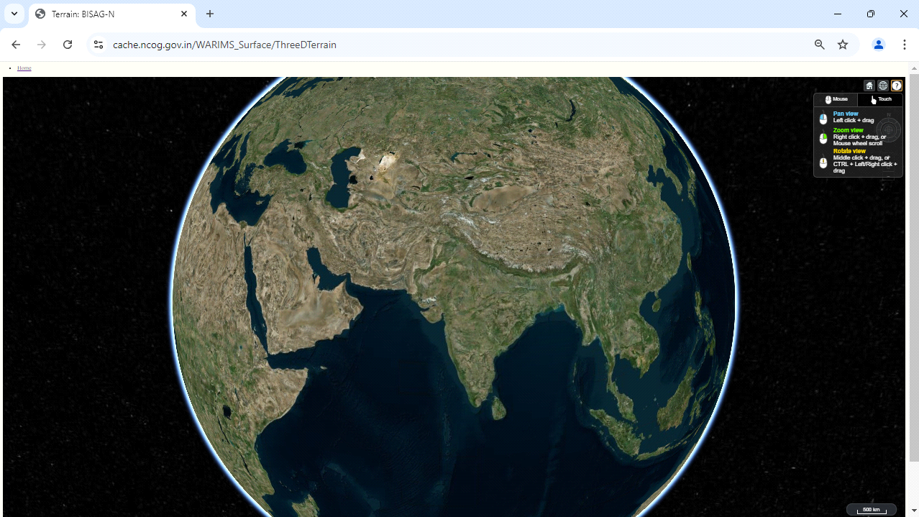

Figure-26 Component Features (ThreeDTerrain: 3D View) of the (LULC)

In Figure-26, the user can view the terrain in three dimensions with available features like pan view, rotate view and zoom view.

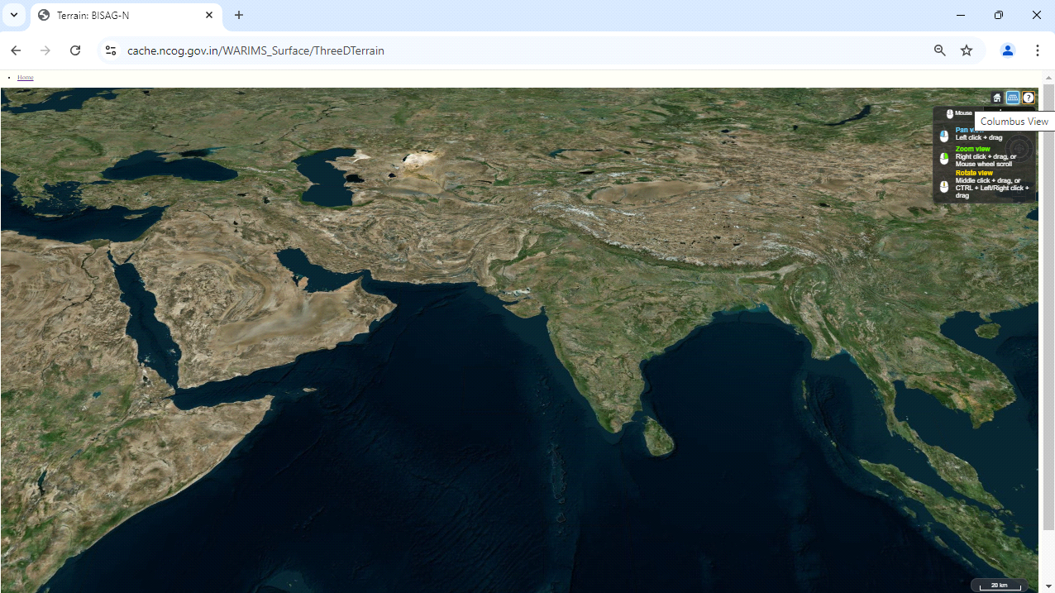

Figure-27 Component Features (ThreeDTerrain: Columbus View) of the (LULC)

Figure-27 shows the user can view the terrain in Columbus view. The user can view the terrain in Columbus view with available features like pan view, rotate view and zoom view.

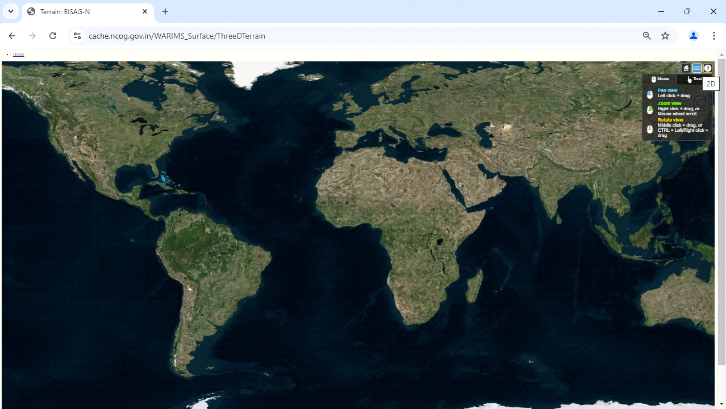

Figure-28 Component Features (ThreeDTerrain: 2D View) of the (LULC)

Figure-28 shows the user can view the Terrain in Two-Dimensional view. The user can view the terrain in two dimensions with available features like pan view, rotate view and zoom view.

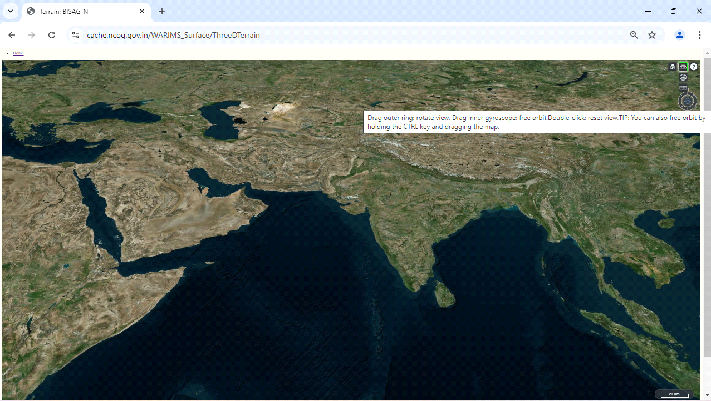

Figure-29 Component Features (ThreeDTerrain: Rotate View) of the (LULC)

Figure-29 shows the user can access the rotate view for each dimension like 2D, 3D and Columbus view. The user can drag outer ring: rotate view. Drag inner gyroscope. Free Orbit. Double-Click: reset view. TIP: user can also free orbit by holding the CTRL key and drag the map.

* **Navigations:**

This tool as shown in Figure-30, allows user to navigate from State > District > Taluka/Tehsil/ Block > Village and user can analyse the required details.

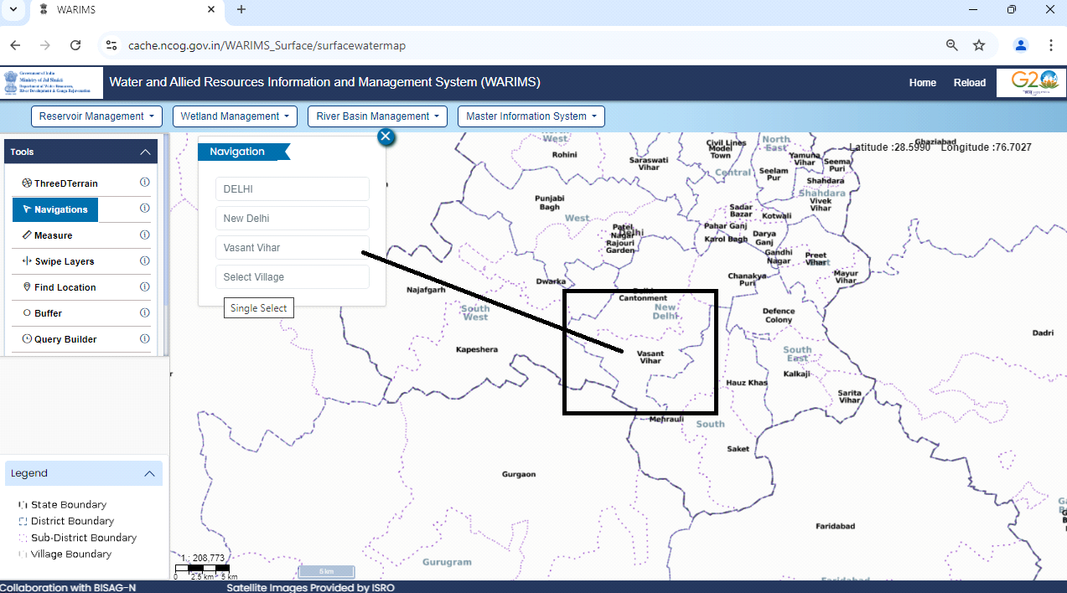

Figure-30 Component Features (Navigations) of the (LULC)

* **Measures:**

The measure tool, measure distances, areas, offsets, and feature locations on a map or scene. User can draw line to measure length, draw polygon to measure area, or click an individual feature to get measurement information.

As in Figure-31 user may select Option-1:

Select Polygon → Measuring Unit (Square Meter/Square Kilometre/Acre/Hectare)

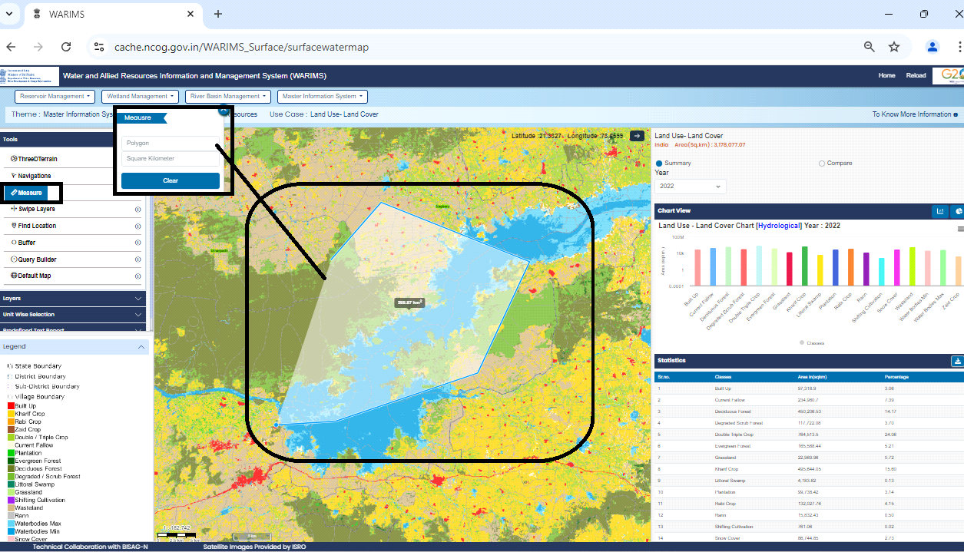

Figure-31 Component Features (Measures: Polygon) of the (LULC)

As in Figure-32 user may select Option-2:

Select Line → Measuring Unit (Meter/Kilometre/Feet)

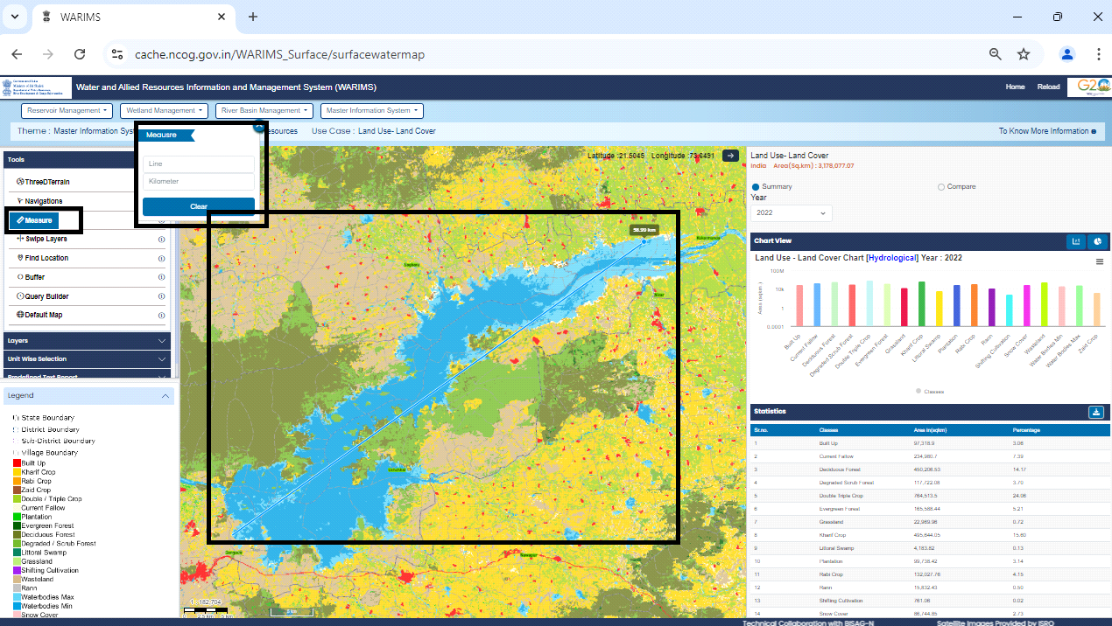

Figure-32 Component Features (Measures: Line) of the (LULC)

* **Swipe Layer:**

As in Figure-33, this feature will help to overlap and compare the 2 layers which could be utilize for temporal analysis, change detection etc. Select 2 desired layers from layers panel, and then select one of the selected layers as left that be static and other as right that slide over.

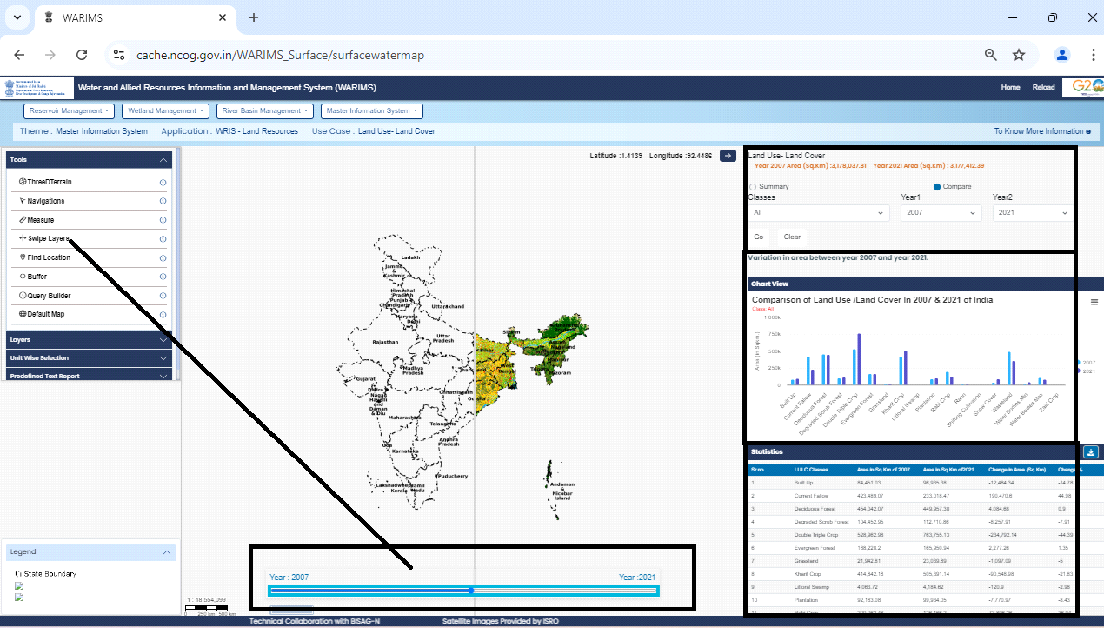

Figure-33 Component Features (Swipe Tool) of the (LULC)

* **Find Location:**

As seen in Figure-34, this feature assists in locating positions with latitude and longitude (Degree Decimal) or by using grid numbers. Additionally, clicking on the map automatically displays the corresponding latitude and longitude coordinates.

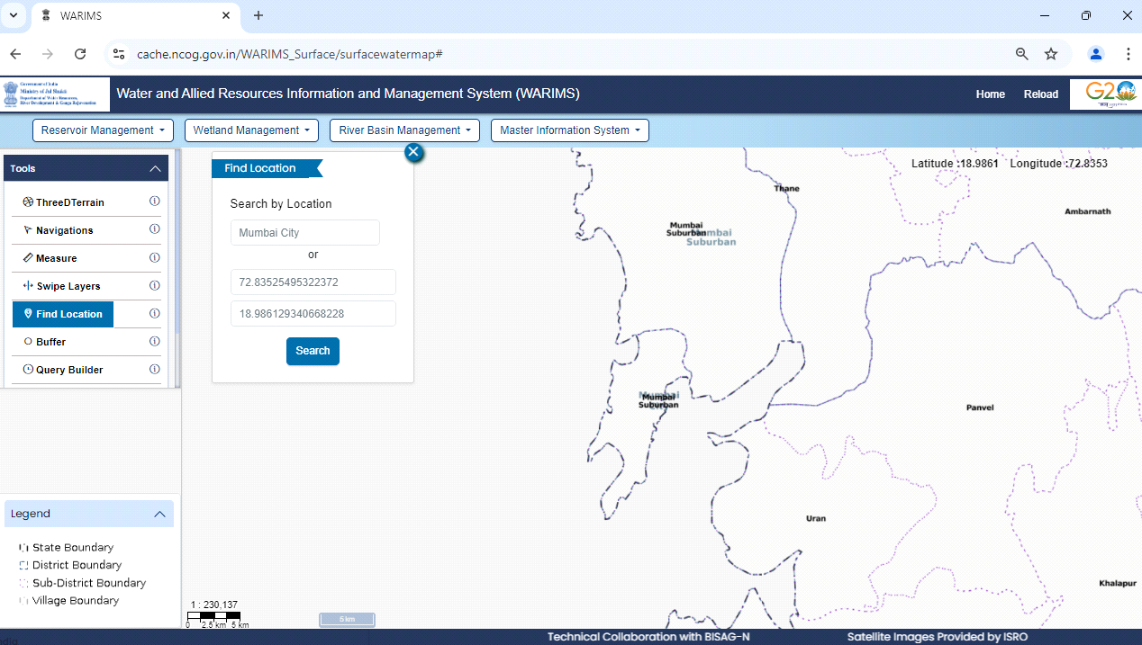

Figure-34 Component Features (Find Location) of the (LULC)

* **Buffer:**

Figure-35 demonstrates this tool which allows user to perform the proximity analysis of the required area. By selecting the area of interest and inputting required range for analysis on the map, infrastructure/ assets within the context/ range area will be displayed.

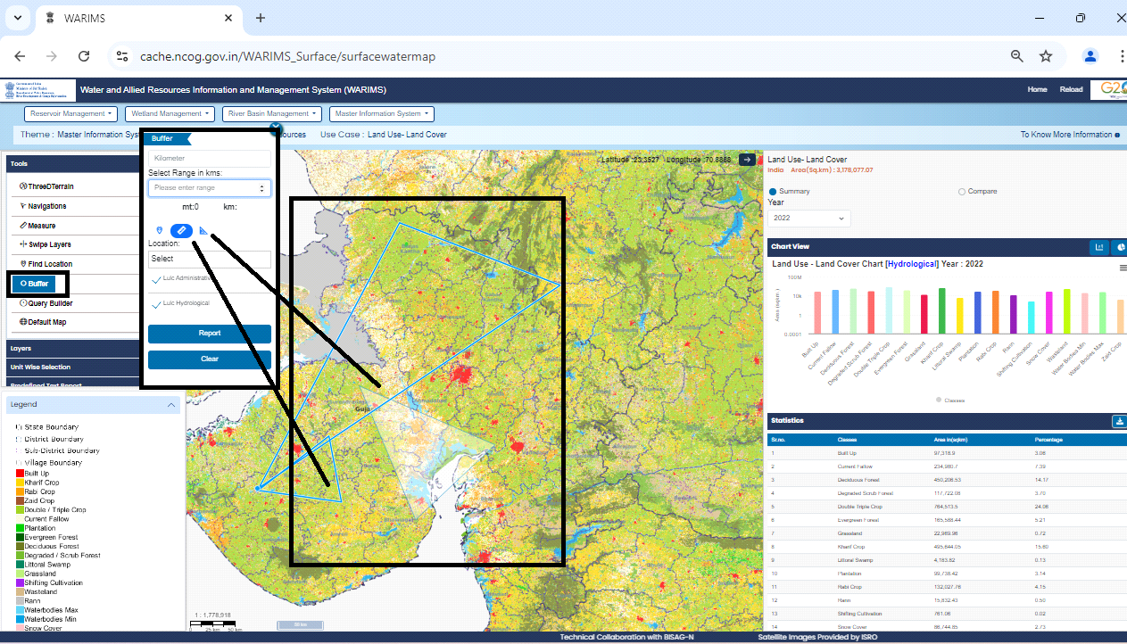

Figure-35 Component Features (Buffer) of the (LULC)

* **Query Builder:**

Refer Figure-36 to see this component feature that provides a graphical user interface for creating query in a simplified way to help users filter records within a particular data layer as per their requirement. It is a tool through which user can filter layer-wise features providing certain conditions on the attributes.

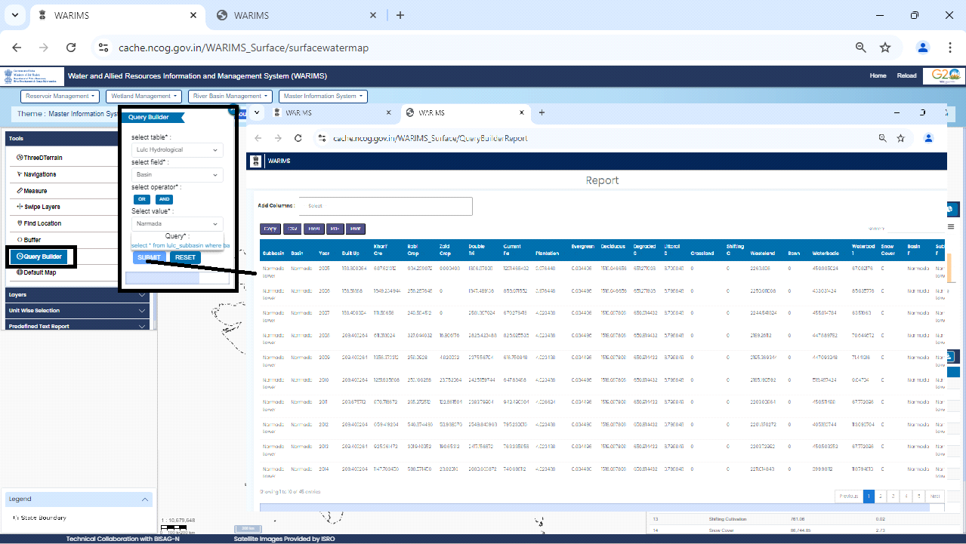

Figure-36 Component Features (Query Builder) of the (LULC)

* **Data Report from Query Builder:**

Based on the inputs given in Query Builder, the data report will be generated that can be further downloaded into various file formats like CSV/Excel/PDF and also can be copied is available for print directly.

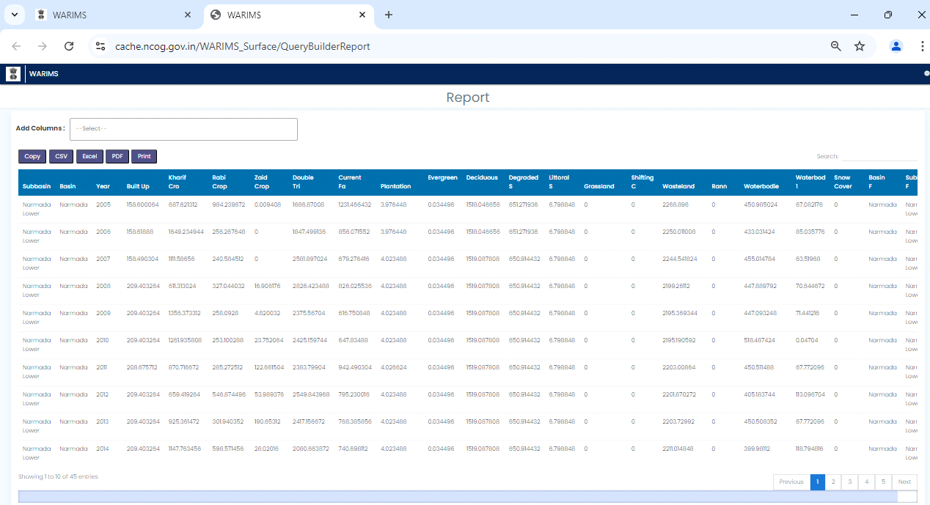

Figure-37 Component Features (Data Report from Query Builder) of the (LULC)

* **Default Map:**

Figure-38 shows this option in which the user has the option to view the map as it was when a new instance was initiated. Thus, while working at any given points of time the user can go back to the standard default view of the map using single click of this button.

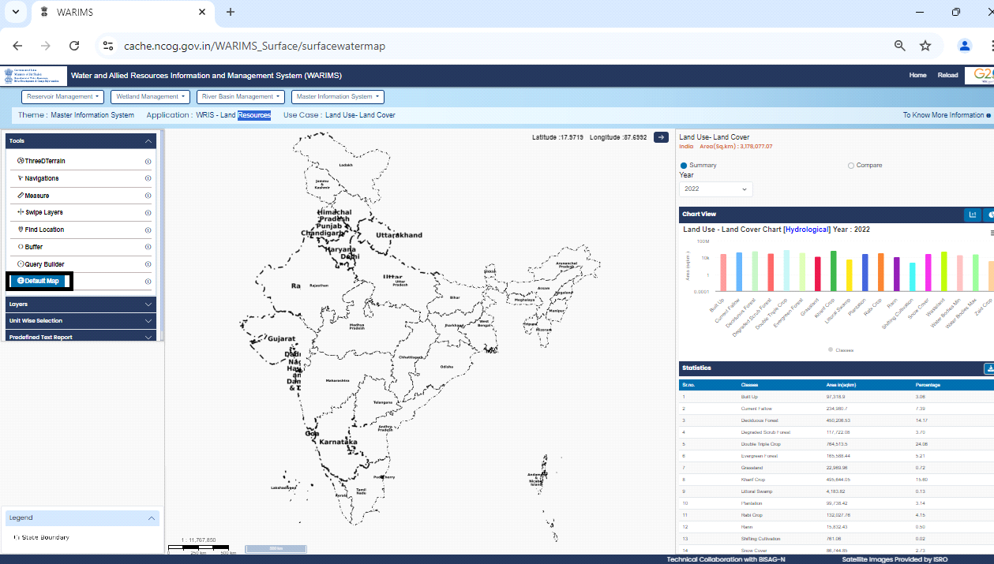

Figure-38 Component Features (Default Map) of the (LULC)

**4.3.2 Layers**

The Figure-39 highlights the “Layers” options in the Left Side Vertical Menu.

The following are the Layers:

|  |  |
| --- | --- |
| * Administrative Boundary * Hydrological Boundary * Base Map Gallery | * Infrastructure * Land Use – Land Cover |

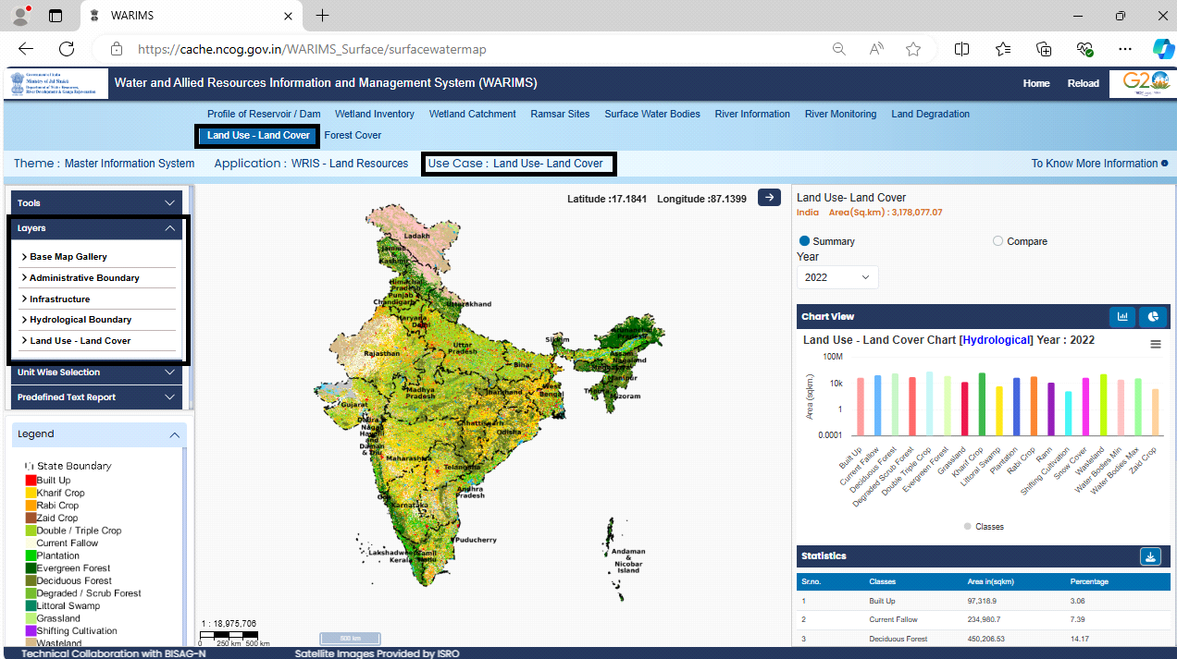

Figure-39 Component Features (Layers – Menu Introduction) of the Land Use Land Cover (LULC)

Find below the description and functionality of each “Layer”:

* **Features of LULC – “Administrative Boundary” within “Layers”:**

As seen in Figure-40, the “Administrative Boundary” within the “Layers” has four options:

* State, District, Sub District and Village

User can access the Administrative Boundary of the Layers using above selective options.

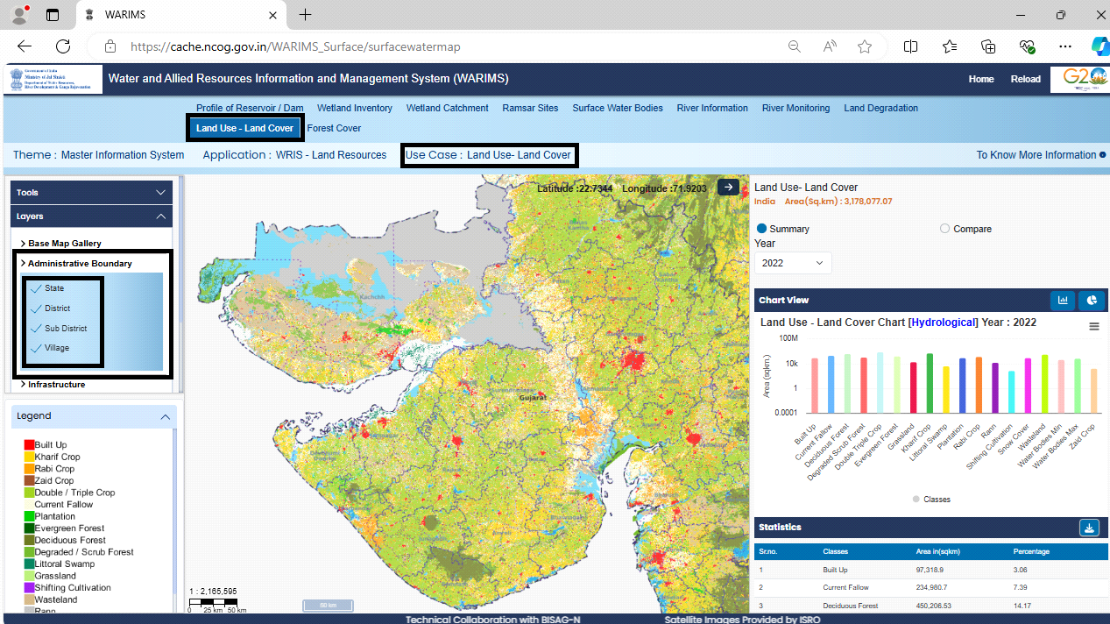

Figure-40 Component Features (Layers – Administrative Boundary) of the (LULC)

* **Features of LULC – “Hydrological Boundary” within “Layers”:**

As seen in Figure-41, the “Hydrological Boundary” within the “Layers” has Six options:

* Basin, Sub Basin, WaterShed, River, Major River, River Polygon

User can access the Hydrological Boundary of the Layers using above selective options.

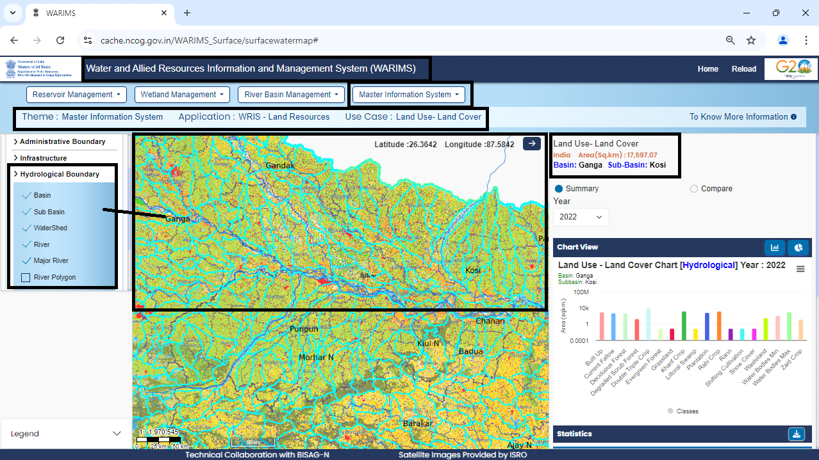

Figure-41 Component Features (Layers – Hydrological Boundary) of the (LULC)

* **Features of LULC – “Base Map Gallery” within “Layers”:**

The “Base Map Gallery” within the “Layers” offer below options:

* High Resolution Images
* OpenStreet Map

As seen in Figure-42, the User can access the Layers using “High Resolution Image” options.

* Goto: WARIMS→ LULC → Layers → Base Map Gallery → High Resolution Image

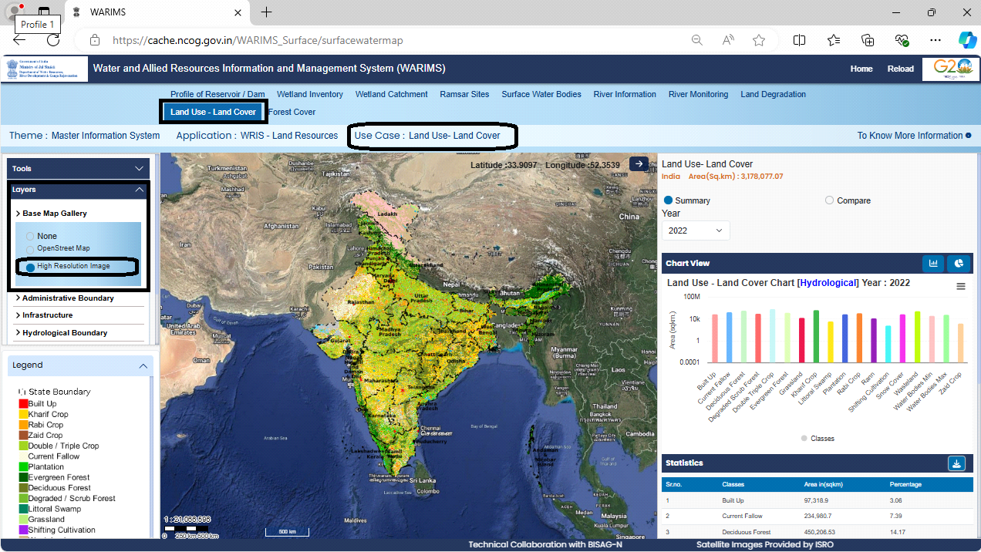

Figure-42 Component Features (Layers – Base Map Gallery with High Resolution Image) of the (LULC)

As seen in Figure-43, the User can access the Layers using “OpenStreet Map” options.

* Goto: WARIMS→ LULC → Layers → Base Map Gallery →OpenStreet Map

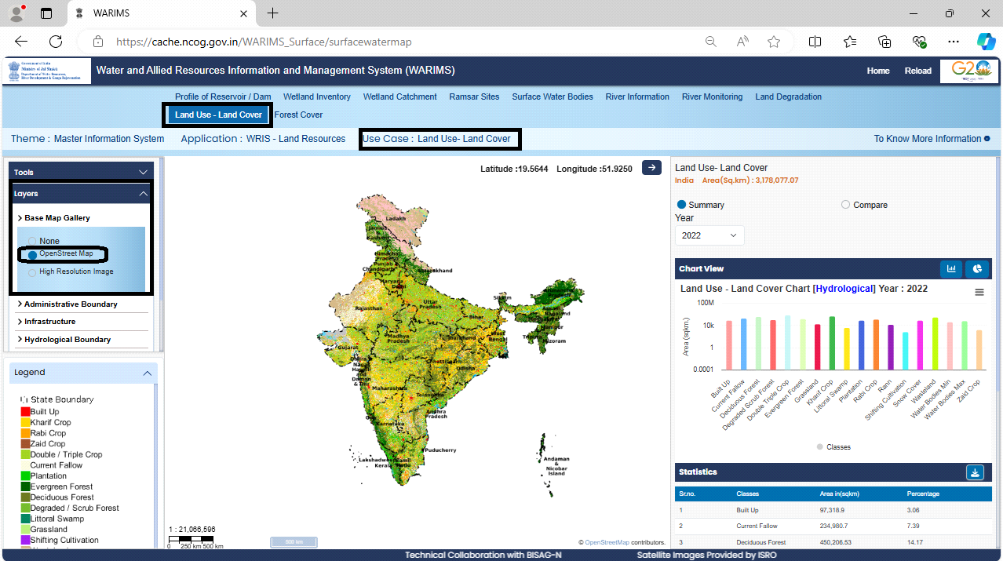

Figure-43 Component Features (Layers – Base Map Gallery with OpenStreet Map) of the (LULC)

* **Features of LULC – “Infrastructure” within “Layers”:**

The “Infrastructure” within the “Layers” has three options:

* Airports, Rail, Road

As in Figure-44, User can access the Infrastructure of the Layers using above selective options.

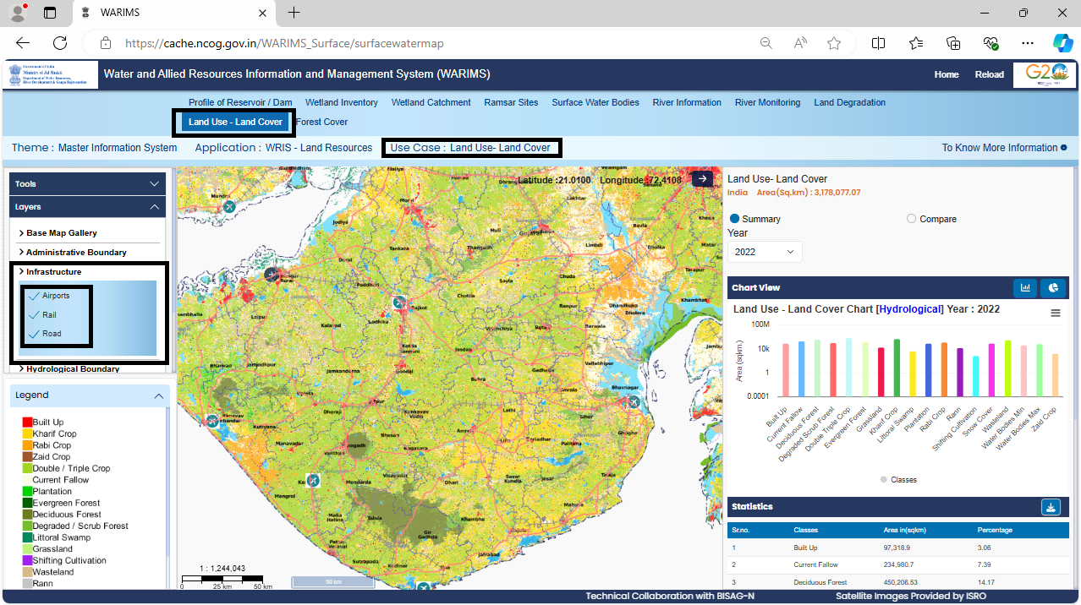

Figure-44 Component Features (Layers – Infrastructure) of the (LULC)

* **Features of LULC – “Land Use-Land Cover” within “Layers”:**

The “Land Use-Land Cover” within the “Layers” has Options from Year 2005-06 to 2022-23

As in Figure-45, User can access the LULC Layers using above selective Years.

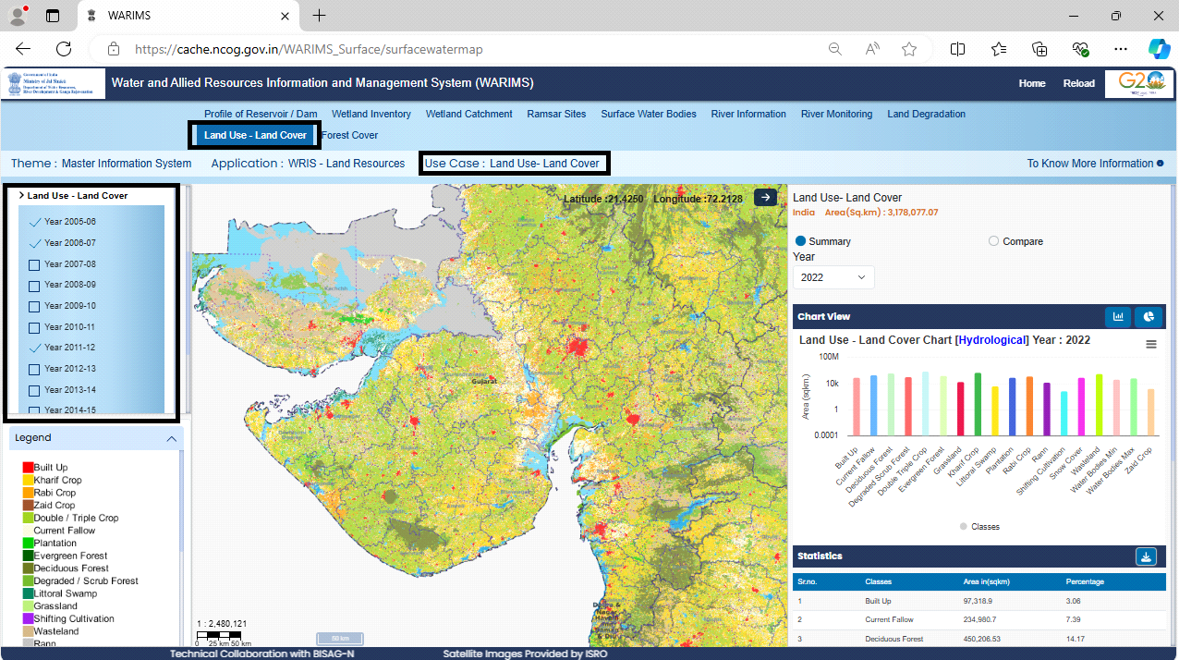

Figure-45 Component Features (Layers – Land Use-Land Cover) of the (LULC)

**4.3.3 Unit Wise Selection**

Unit Wise Selection offers two options, select either of any one option:

* Hydrological
* Political
* **As seen in Figure- 46 & 47, the user can access the Land Use-Land Cover: Hydrological (Unit Wise Selection)**

Step to select Basin: Unit Wise Selection → Hydrological → Select →Basin

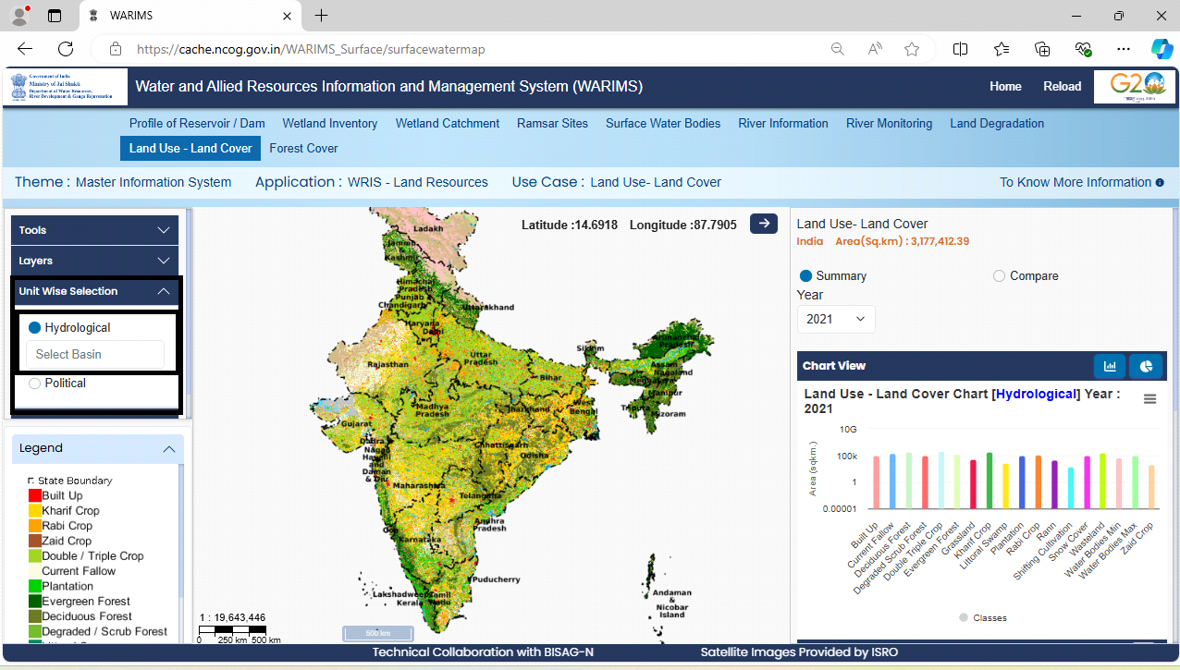

Figure-46 Component Features (Unit Wise Selection – Hydrological) of the (LULC)

Step to select Sub-Basin: Unit Wise Selection → Hydrological → Select →Basin →Sub-Basin

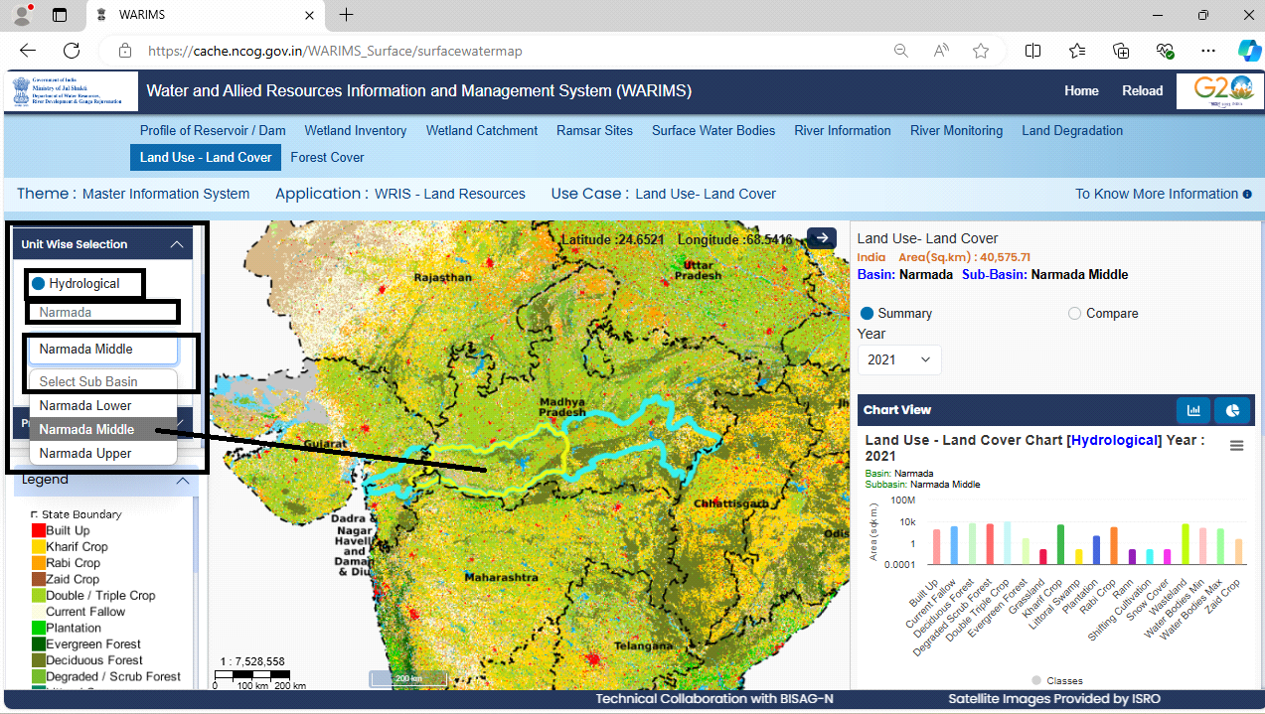

Figure-47 Component Features (Unit Wise Selection – Hydrological → Basin → Sub Basin) of the (LULC)

* **As seen in Figure-48, User can access the LULC: Political (Unit Wise Selection)**

Steps: Unit Wise Selection → Political → Select →State →District

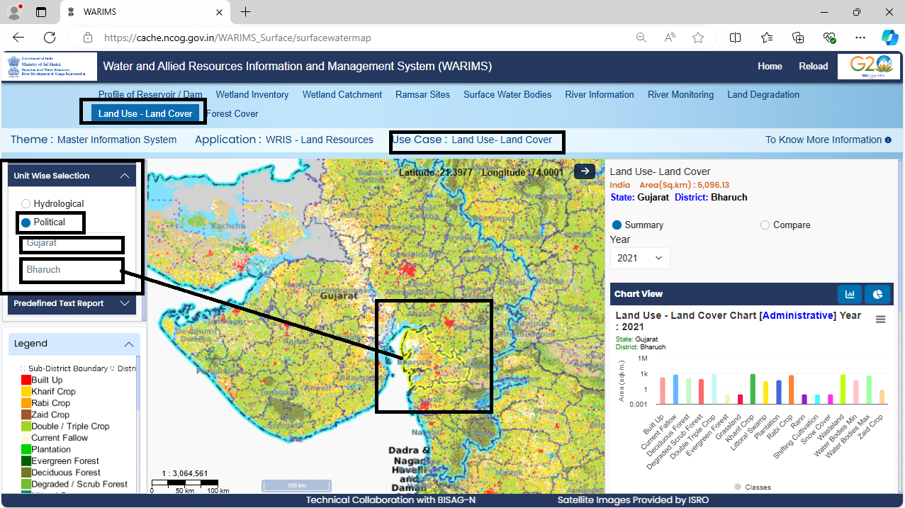

Figure-48 Component Features (Unit Wise Selection – Political → State → District) of the (LULC)

**4.3.4 Predefined Text Report**

The Predefined Text Report have two options, user may select either of any one option:

* Hydrological and b) Political
* **As shown in Figure-49, User can access the LULC: Hydrological (Predefined Text Report)**

Steps: Predefined Text Report → Hydrological → Basin →Sub-Basin→ Classes → Year

Then Click on the Button “Download Data” to receive the Predefined Text Report for the selected Hydrological Classes.

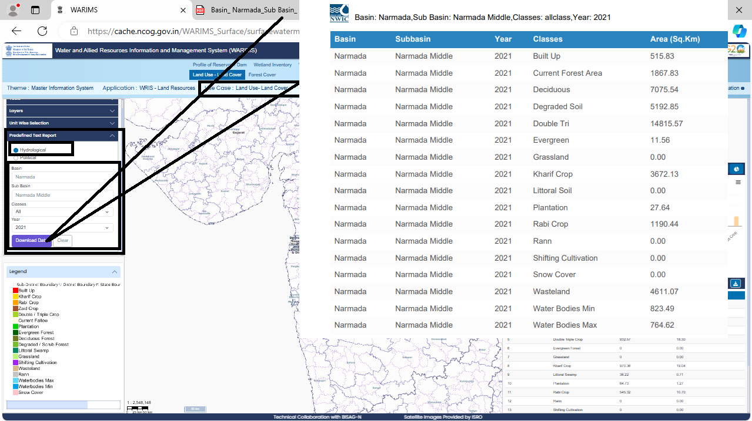

Figure-49 Component Features (Predefined Text Report →Hydrological) of the (LULC)

* **As seen in Figure-50, user can access the LULC: Political (Predefined Text Report)**

Step: Predefined Text Report → Political →State →District → Classes → Year

Then Click on the Button “Download Data” to receive the Predefined Text Report for the selected Political Classes.

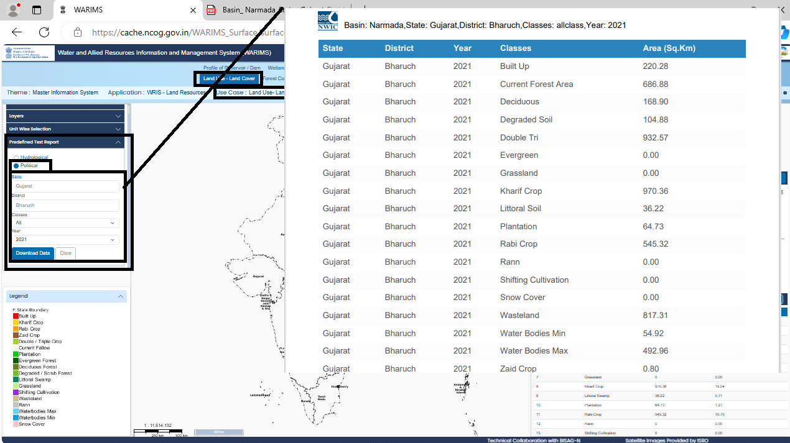

Figure-50 Component Features (Predefined Text Report →Political) of the (LULC)

**4.3.5 Legend**

Legend includes the different classes as below: (As shown in Figure-51)

|  |  |  |
| --- | --- | --- |
| * Built-up * Kharif Crop * Rabi Crop * Zaid Crop * Double/Triple Crop * Plantation | * Evergreen Forest * Deciduous Forest * Degraded / Scrub Forest * Littoral Swamp * Grassland * Shifting Cultivation | * Wasteland * Rann * Waterbodies Max * Waterbodies Min * Snow Cover * Current Fallow |

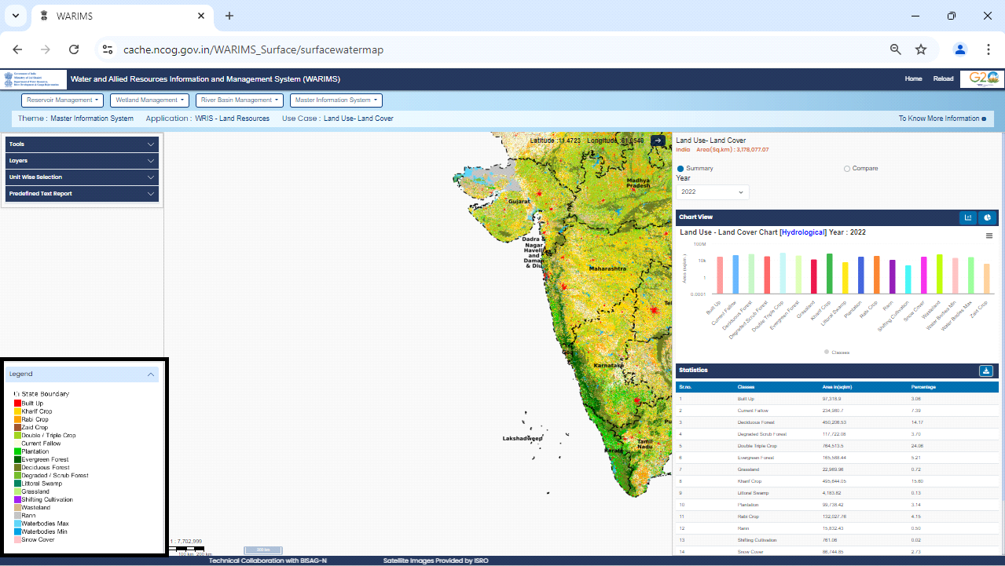

Figure-51 Component Features (Legend: State Boundary for each Classes) of the (LULC)

**4.3.6 Reports**

This feature offers Reports for the Summary and Comparison.

* **Summary Report:** User can access the Land Use-Land Cover

As in Figure-52, Select the Year as an input for generating the summary report.

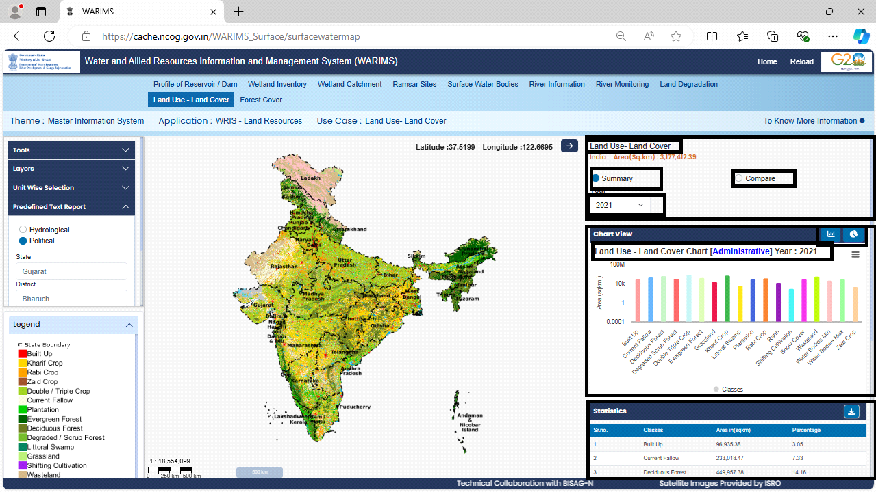

Figure-52 Component Features (Summary Report – Bar Chart + Statistics) of the (LULC)

Get the Summary Report into formats: (As in Figure-53)

* ChartView (Bar Chart/Pie Chart)
* Statistical Data (Downloadable)

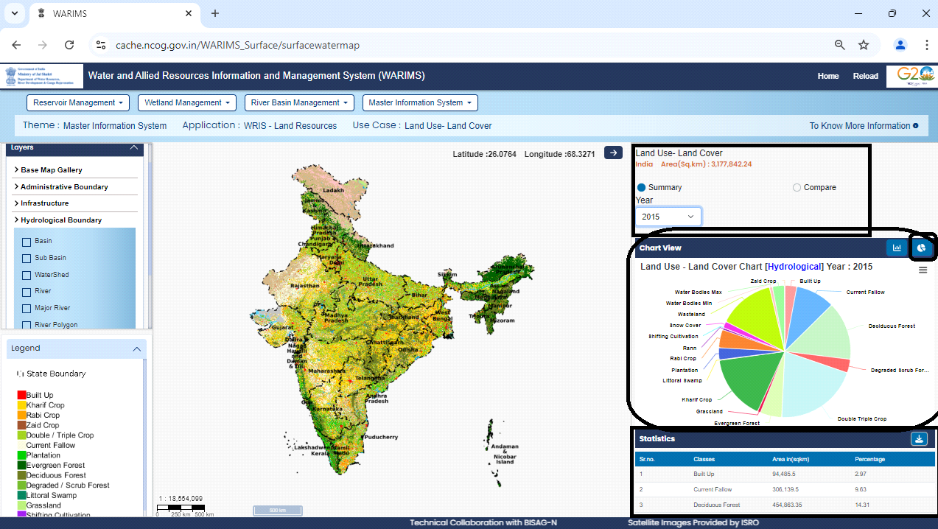

Figure-53 Component Features (Summary Report – Pie Chart + Statistics) of the (LULC)

* **Comparative Report:** Get Comparative Report into formats:

As in Figure-54, Comparative Report with Bar Chart, Statistical Report and Swipe Layer Component for Spatial Temporal Analysis.

Step: Select Compare Button → Select the Class → Select Year1 and Year2 and Click Go Button

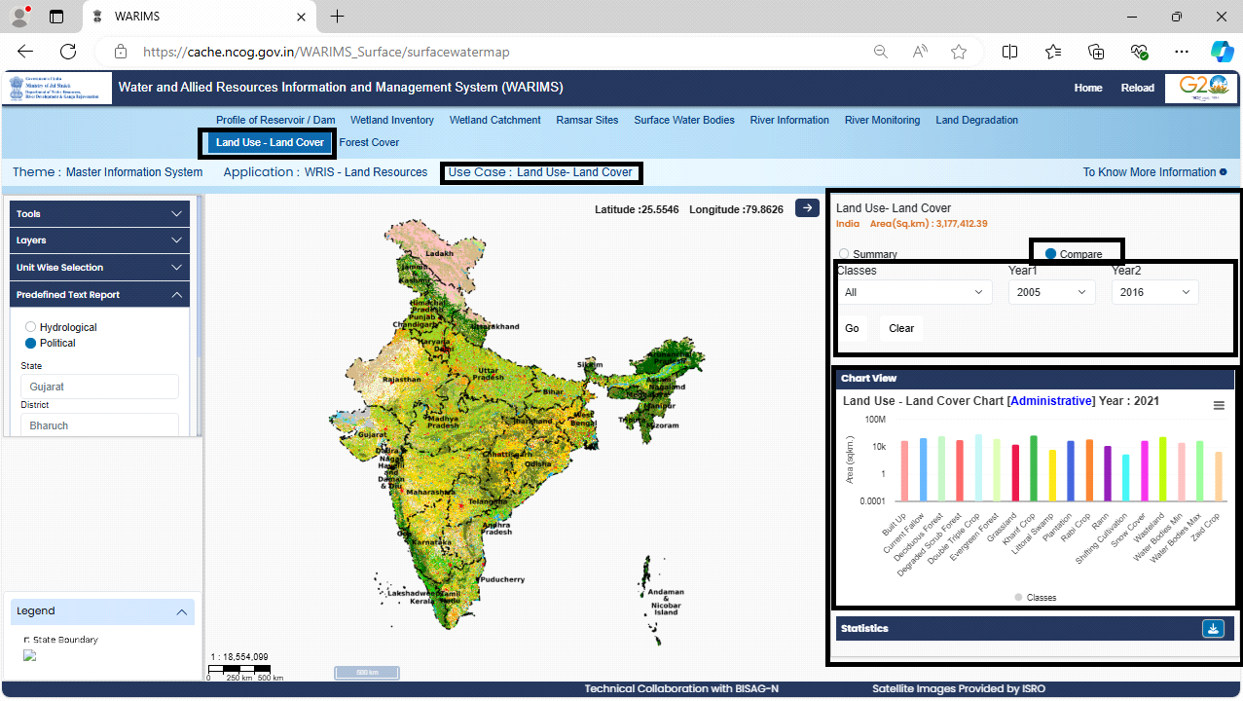

Figure-54 Component Features (Comparative Report – Bar Chart + Statistics) of the (LULC)

**4.3.7 Statistics Report**

The Summary and Comparison Reports are available in statistical form that can be useful for user to review and perform the analysis with statistical data. As in Figure-55, the statistical report can be available in downloadable format like: CSV/Excel/PDF/Doc.

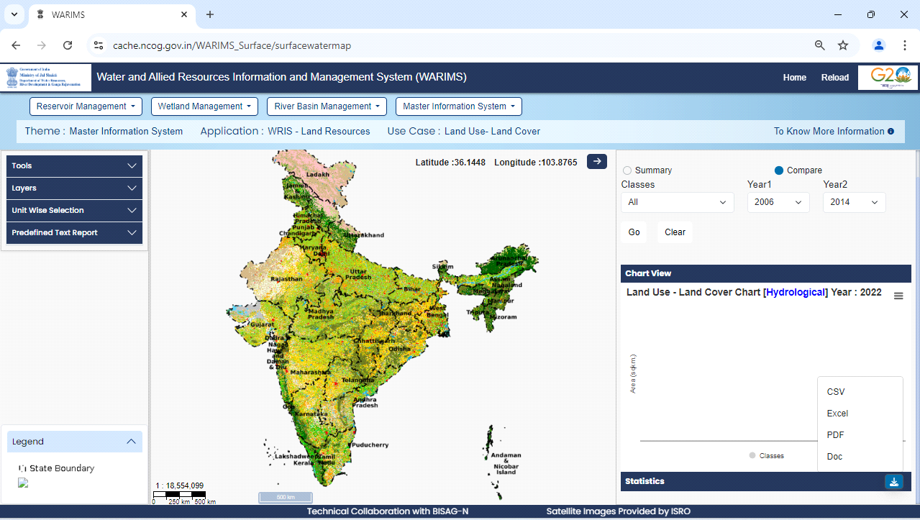

Figure-55 Component Features (Statistics Report) of the (LULC)

* **Conclusion**

The system utilizes the methodology to create and update LULC maps and datasets, which are essential for various applications such as scientific research, industrial sitting, land improvement, watershed and coastal zone management, water resource management, and agricultural productivity improvement.

The system uses high-resolution satellite imagery from various sources, for mapping LULC at different scales. The process involves data preparation, interpretation, ground truthing, post-classification correction, and output generation using both vector-based on-screen visual interpretation and raster-based image classification methods.

The system emphasizes the importance of monitoring LULC changes for sustainable development and planning. It describes the generation of LULC maps at various administrative levels, from the country to the state/district/basin/sub-basin, and the provision of detailed LULC information and temporal changes through reports, graphs, charts, and statistics.

The system development has reviewed and implemented data integration, and other system related dependencies, risks, and testing. Changes in Land Use/Land Cover (LULC) are influenced by both human activities and natural forces. Effective monitoring of these changes is now available for the end-users like planners, policymakers, decision makers, administrators, academicians, farmers and public in general. The end-users can access this application to foster informed decisions for sustainable development. Finally, a comprehensive information system to track LULC over time is developed, that provides necessary insights to efficate planning for sustainable land management.

The web application provides all the necessary features in the menu options. The Application is accessible for the Classification of Land Use Land Cover for Various Classes of Hydrological and Political Features for Years. The Summary Report with Comparative statistics is available between two selected years. The statistical data report is available in printable formats.

In conclusion, the system provides comprehensive framework that is developed for LULC mapping system, which helps the user to understand land use patterns and their changes over time, ultimately supporting informed decision-making for sustainable land management and resource utilization.

**6. Outcome**

The project provides the stakeholders with temporal changes of LULC over Indian administrative and hydrological regions with maps, chart/graph and statistics based upon user specific query which enables informed decision-making for sustainable land management. Updated LULC information from various agencies on single frame helps identify environmental threats and optimize land use across sectors like agriculture and urban planning, supporting resource-efficient development efforts.

* **Future Scope**
* System can be utilized for all the sectoral planning of land resources.
* The application can be made available in mobile application.
* The scalable system architecture allows the technologies, data framework, and testing strategies to adapt and support future governance needs.

**8.** **Ideation**

Innovative applications of Land Use and Land Cover (LULC) data can include creating:

* AI-powered monitoring systems for tracking land changes, developing sustainability dashboards for decision-making, leveraging citizen science platforms for local land observations.
* Additionally, automated environmental impact assessment tools and conservation planning resources can guide sustainable development by analysing potential impacts and enhancing biodiversity protection.

These innovations may enable practical, data-driven solutions for sustainable land resource management across various sectors.

* **Reference Material for Techno-functional Understanding**
* BSR for the Land Use Land Cover (From NWIC)
* ISRO/NRSC: NRSA/RSGlS-AA/NRC/NLULC- AWiFS/PROJREP/R01/JUN07,
* NRSC (2014), Land Use / Land Cover database on 1:50,000 scale, Natural Resources Census Project, LUCMD, LRUMG, RSAA, National Remote Sensing Centre, ISRO, Hyderabad
* Ranganath R. Navalgund, Remote sensing applications: An overview, Current Science, Vol. 93, No. 12, 25 December 2007
* Manual - Preparation of Geo Spatial Layers using High Resolution (Cartosat-1 PAN -r LISS-IV Mx) Orthorectified Satellite Imagery, RS& GIS AA, NRSC, ISRO, March-2012

**Annexure – 1: BSR for Geoviewer-(From NWIC)**

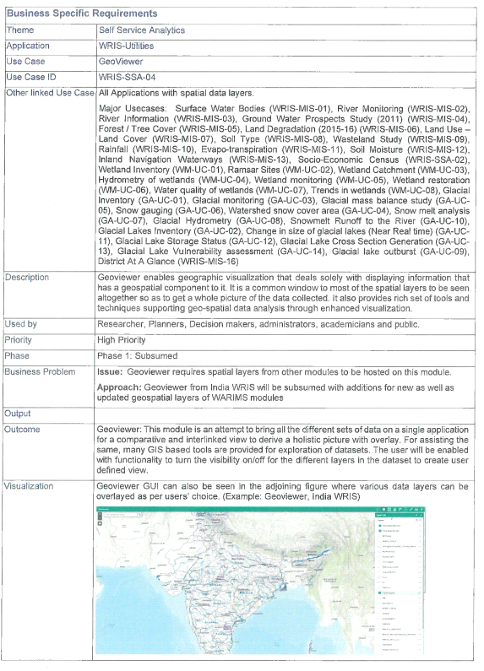Annexure-1 (Page-1/5)

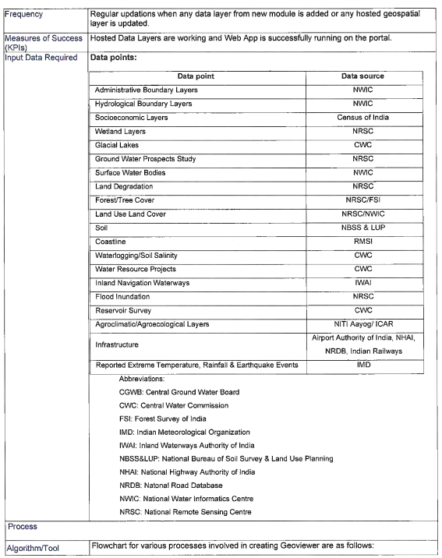

Annexure-1 (Page-2/5)

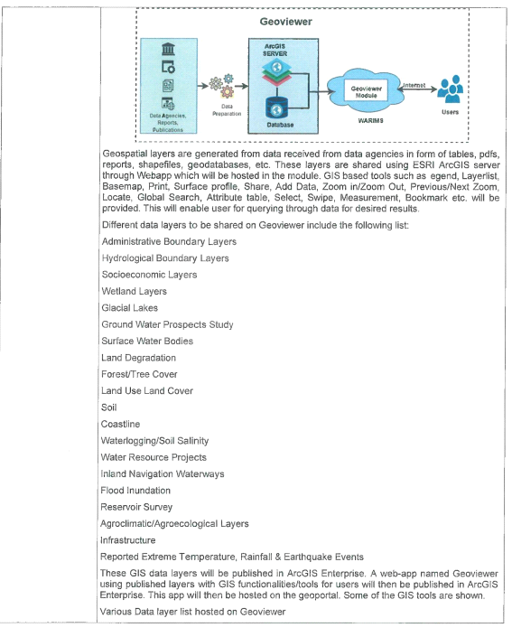Annexure-1 (Page-3/5)

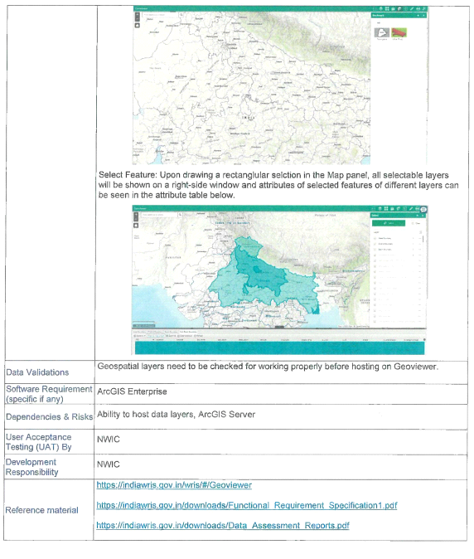Annexure-1 (Page-4/5)

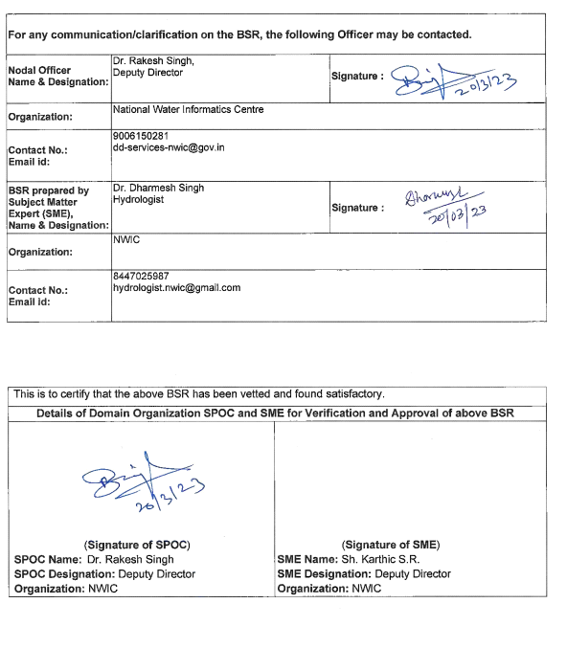

Annexure-1 (Page-5/5)

**Annexure – 2: Project Blueprint Synopsis**

|  |  |
| --- | --- |
| **Project** | GeoViewer-WRIS-SSA-04 |
| **Application** | WRIS-Utilities |
| **Theme** | Self Service Analytics |
| **Platform** | The Water and Allied Resources Information and Management System (WARIMS) |
| **Initiative For** | Department of Water Resources, River Development and Ganga Rejuvenation,  Ministry of Jal Shakti (MoJS) |
| **Developed By** | Bhaskaracharya National Institute for Space Applications and Geo-informatics (BISAG-N), Ministry of Electronics and Information Technology, Government of India. |

**Specification Outline**

Land Cover is defined as observed physical features on earth's surface. When an economic function is added, it becomes Land Use. Timely monitor the changes are necessary in LULC pattern for a particular region. Change detection helps audience’ answers to important questions which is essential for sustainable development. Change detection information of LULC over a period of time is primary requirement in all planning activities.

**End Users**

Researcher, Planners, Decision makers, administrators, academicians and public.

**Governance Need**

Geoviewer necessitates that spatial layers from other modules be hosted within this module.

* **Scope**

LULC serves as a model parameter required in many thematic studies. LULC mapping address Kharif/ Rabi / Zaid crops, green/season wastelands, surface water bodies, forest vegetation and other high temporal LULC practices using satellite remote sensing data.

* **Success Criteria**

To generate spatial change data on LULC. To enable end users initiate the appropriate measure to prevent / review degradation / development of natural resources.

**Technologies Utilized and Supported**

|  |  |
| --- | --- |
| Geospatial : | Image Processing and Remote Sensing Techniques |
| Web Application : | Java SpringBoot 4.0, GeoWebCache, JQuery 3.7.4 |
| Front-end : | OpenLayers 6, Thymeleaf 3.1.2, Bootstrap 5.3 (CSS & JS), HTML5 |
| GIS Software : | QGIS 3.32 Lima |
| Cloud : | MeghRaj, NIC |
| Database : | PostgreSQL 9.4 |

* **Schedule\***

|  |  |  |  |
| --- | --- | --- | --- |
| * Milestones | * Phases | * Work Days | * Team |
| * 1 | * Requirement: * Understanding and Analysis & Review | * 5 | * Project Manager, Project Analyst |
| * 2 | * System Design | * 3 | * UI/UX Graphics & Web Designer |
| * 3 | * System Development | * 10 | * Software Developers |
| * 4 | * System Quality Testing | * 2 | * Software Quality Tester |
| * 5 | * User Acceptance Test (UAT) | * 5 | * NWIC |

* *Overall project activities is planned, monitored and reviewed by project manager and reported to project director.

**Annexure-3: List of Figures-System Requirement, Design and Development**

|  |  |  |
| --- | --- | --- |
| **Sr. No.** | **Figure Number and Name** | **Page No** |
| 1 | Figure-1 Flow Diagram for LULC Monitoring System | 1 |
| 2 | Figure-2 System flow of the Land Resource Management for LULC | 1 |
| 3 | Figure-3 High Priority for LULC mapping | 2 |
| 4 | Figure-4 System Flow: End Users accessing Land Use Land Cover (LULC) | 2 |
| 5 | Figure-5 Flowchart: Functional Overview of LULC Monitoring | 3 |
| 6 | Figure- 6 Sequence Diagram for the task:  Visualization on Map at country to State/District/Basin/Sub-Basin Level for Admin/ Hydrological boundary wise. | 4 |
| 7 | Figure-7 Sequence Flow for Expected High Resolution Map | 4 |
| 8 | Figure-8 Sequence Diagram of class-wise graphical data presentation of Administrative Set-Up | 5 |
| 9 | Figure-9 Sequence Diagram of class-wise graphical data presentation of Hydrological Set-Up | 5 |
| 10 | Figure-10 Sequence Diagram of Comparing two years with single class or all classes | 5 |
| 11 | Figure-11 Comparative analysis of classes and between two years for change identification | 6 |
| 12 | Figure-12 Sequence Flow of Pre-define Text Report Generate | 6 |
| 13 | Figure-13 Data Architecture of the System | 9 |
| 14 | Figure-14 GIS based System Architecture | 11 |
| 15 | Figure-15 ER Diagram for LULC data | 12 |
| 16 | Figure-16 GIS & Environment Data Attribute | 13 |
| 17 | Figure-17 LULC Data Attribute | 13 |
| 18 | Figure-18 Class Diagram of classes: lulc_subbasin and lulc_district | 14 |
| 19 | Figure-19 Sequence Diagram of Data Integration and Development | 16 |
| 20 | Figure-20 Gantt chart | 20 |

**Annexure-4: List of Figures-User Manual**

|  |  |  |
| --- | --- | --- |
| **Sr. No.** | **Figure Number and Name** | **Page No** |
| 1 | Figure-21 Dashboard Landing Page | 23 |
| 2 | Figure-22 Themes on the Dashboard Landing Page | 23 |
| 3 | Figure-23 Access Land Use Land Cover (LULC) | 24 |
| 4 | Figure-24 Home Page of the Land Use Land Cover (LULC) | 24 |
| 5 | Figure-25 Component Features (Tools – Menu Introduction) of the LULC | 25 |
| 6 | Figure-26 Component Features (ThreeDTerrain: 3D View) of the LULC | 26 |
| 7 | Figure-27 Component Features (ThreeDTerrain: Columbus View) of the LULC | 26 |
| 8 | Figure-28 Component Features (ThreeDTerrain: 2D View) of the LULC | 27 |
| 9 | Figure-29 Component Features (ThreeDTerrain: Rotate View) of the LULC | 27 |
| 10 | Figure-30 Component Features (Navigations) of the LULC | 28 |
| 11 | Figure-31 Component Features (Measures: Polygon) of the LULC | 28 |
| 12 | Figure-32 Component Features (Measures: Line) of the LULC | 29 |
| 13 | Figure-33 Component Features (Swipe Tool) of the LULC | 29 |
| 14 | Figure-34 Component Features (Find Location) of the LULC | 30 |
| 15 | Figure-35 Component Features (Buffer) of the LULC | 30 |
| 16 | Figure-36 Component Features (Query Builder) of the LULC | 31 |
| 17 | Figure-37 Component Features (Data Report from Query Builder) of the LULC | 31 |
| 18 | Figure-38 Component Features (Default Map) of the LULC | 32 |
| 19 | Figure-39 Component Features (Layers – Menu Introduction) of the LULC | 32 |
| 20 | Figure-40 Component Features (Layers – Administrative Boundary) of the LULC | 33 |
| 21 | Figure-41 Component Features (Layers – Hydrological Boundary) of the LULC | 33 |
| 22 | Figure-42 Component Features (Layers-Base Mapgallery with High Resolution Image) of LULC | 34 |
| 23 | Figure-43 Component Features (Layers – Base Map Gallery with OpenStreet Map) of LULC | 34 |
| 24 | Figure-44 Component Features (Layers – Infrastructure) of the LULC | 35 |
| 25 | Figure-45 Component Features (Layers – Land Use-Land Cover) of the LULC | 35 |
| 26 | Figure-46 Component Features (Unitwise Selection – Hydrological) of the LULC | 36 |
| 27 | Figure-47 Component Features (Unitwise Selection – Hydrological Basin & Subbasin) of LULC | 36 |
| 28 | Figure-48 Component Features (Unitwise Selection – Political à State & District) of the LULC | 37 |
| 29 | Figure-49 Component Features (Predefined Text Report - Hydrological) of the LULC | 37 |
| 30 | Figure-50 Component Features (Predefined Text Report - Political) of the LULC | 38 |
| 31 | Figure-51 Component Features (Legend: State Boundary for each Classes) of the LULC | 38 |
| 32 | Figure-52 Component Features (Summary Report – Bar Chart + Statistics) of the LULC | 39 |
| 33 | Figure-53 Component Features (Summary Report – Pie Chart + Statistics) of the LULC | 39 |
| 34 | Figure-54 Component Features (Comparative Report – Bar Chart + Statistics) of the LULC | 40 |
| 35 | Figure-55 Component Features (Statistics Report) of the LULC | 40 |

**Annexure-5: List of Tables**

|  |  |  |
| --- | --- | --- |
| **Sr. No.** | **Table Number and Name** | **Page No** |
| 1 | Table-1: Instrumental component features | 7 |
| 2 | Table-2: Layers | 7 |
| 3 | Table-3: Other Features | 8 |
| 4 | Table-4: Scalable Technology Framework (Utilized and Supported) | 8 |
| 5 | Table-5: Significance described for each technology as mentioned in Table-4 | 8 |
| 6 | Table-6: System Design Layers | 10 |
| 7 | Table-7: Undertakings | 17 |
| 8 | Table-8: Project Milestones | 18 |
| 9 | Table-9: Project Development Phases and Tasks | 18 |
| 10 | Table-10: Project Development Resources | 19 |
| 11 | Table-11: Project Schedule | 19 |
| 12 | Table-12: Change Management | 21 |
| 13 | Table-13: Testing Checklist | 22 |

**Annexure-6: Abbreviations**

|  |  |
| --- | --- |
| **Abbreviations** | **Full Name** |
| API | Application Programming Interface |
| AWiFS | Advanced Wide Field Sensor) |
| BSR | Business Specification Requirement |
| CRS | Common Reference System |
| DSS | Decision Support Systems |
| EO | Earth Observation |
| ESA | European Space Agency |
| ETL | Extract, Transform, Load |
| FPGA | Field-Programmable Gate Array |
| FRS | Forest Resources Survey |
| GIS | Geographic Information System |
| IaaS | Infrastructure-as-a-Service |
| India-WRIS | India Water Resources Information System |
| IRS | Indian Remote Sensing Satellite |
| ISO | International Organization for Standardization |
| IT | Information Technology |
| IWRM | Integrated Water Resources Management |
| KPI | Key Performance Indicator |
| LGD | Local Government Directory, Government of India |
| LISS | Linear Imaging Self-Scanning Sensor |
| LULC | Land Use Land Cover |
| MoJS | Ministry of Jal Shakti |
| MODIS | Moderate Resolution Imaging Spectroradiometer |
| NRSC | National Remote Sensing Centre |
| NWIC | National Water Informatics Centre |
| OGC | Open Geospatial Consortium |
| O&M | Operations and Maintenance |
| PaaS | Platform-as-a-Service |
| QA | Quality Assurance |
| R2 | Resourcesat-2 |
| R&D | Research and Development |
| RISAT | Radar Imaging Satellite |
| SAR | Synthetic Aperture Radar |
| SoI | Survey of India |
| SQL | Structured Query Language |
| TBD | To Be Determined |
| UAT | User Acceptance Testing |
| UAV | Unmanned Aerial Vehicle |
| UI | User Interface |
| UX | User Experience |
| WIMS | Water Information Management System |